Module 2 Part 8 – The Basics of Self Disclosure

This section corresponds with middle school transition classroom materials for Module 2 Activity 2.
Introduction
Objective: You will
- Put the steps for receiving accommodations in college in order and tell who is responsible for initiating each step.
- Show how to hold a professional meeting while clearly talking about a disability and the accommodations you need.
Estimated time needed: 30-45 minutes
Additional materials needed:
- Internet access
- Pencil and paper

Introduction
Learn About It
Step 1: Contact DSS
Step 2: Talk to DSS Coordinator
Step 3: Accommodations
Step 4: DSS Letter
Step 5: Professors Give Accommodations
Step 6: Monitor Accommodations
Remembering the Steps
Meeting with Your Professor
Things to Remember
What do you Think?
Wrapping up
Objective Check
Digging Deeper

Introductory Video

Parents Chime In
Your child is still at an age where he/she needs your support, but before you know it, he/she will be ready to be independent. After graduation from high school, your child will need to be able to make decisions about self-disclosure and on his/her own. One thing you can do now is to become knowledgeable of the process and be there to practice that process. This practice will make your child more comfortable in high school and beyond.
Learn About It
College…it might be a distant dream that you are only now beginning to think about. While it is a long way away, the time to start preparing is now. Taking the unknown away from the college process can make you see that it is an achievable goal, but there are some things that you need to know specifically about how to receive accommodations.
Receiving accommodations in college is not only your responsibility, it is also a formal process. It begins with you contacting the office of Disability Support Services or the 504 Coordinator. It can seem overwhelming, but with the right support and preparation, you will be able to set up the accommodations that you need to be successful. Each college is a little different in how they process student needs in relation to disabilities. They might have a different name for the office or coordinator or a slightly different process with different forms. In spite of the differences, the general process is normally similar in all settings in terms of the order of the steps to take and the person responsible for initiating each step. Today you are going to look at the typical steps to take with most colleges when deciding to disclose your disability.
Step 1: Contact the Office of Disability Support Services
Person Responsible: You
The very first step begins with YOU contacting the office of Disability Support Services or the comparable office at your college if it has a different name. You must register as a student with a disability. If you do not take the initiative to make this appointment, you will not receive accommodations. Make sure you are prepared when you go.
You will need current documentation of your disability from a licensed professional.
IEP’s typically do not qualify as current documentation. You can check the college’s website to see what they require, or you can ask the person in the office when you call to set up your appointment.

Step 2: Discuss Your Accommodations with the DSS Coordinator
Person Responsible: You
Step two is also your responsibility. You have to be prepared to talk about
- Accommodations you have used in the past
- Why the accommodations worked
- What you think you will need in college
- What has been successful for other students in college
By practicing your formal self-disclosure from the previous lesson, you will be much more comfortable in this meeting.
Step 3: DSS Office Determines Your Accommodations
Person Responsible: DSS Coordinator
The person in charge of accommodations (regardless of the title) will review your documentation and determine if you are eligible for services. If you are eligible, he/she will
- Review your file
- Decide what accommodations you will receive from the college
- Set up a meeting with you
- Give you a letter that you will give to your professors detailing the accommodations for which you qualify
Step 4: Give Your Letter of Accommodations to Your Professors
Person Responsible: You
It is your responsibility to give the accommodation letter to your professors and be prepared to talk with the professor about how to receive your accommodations. You will want to set up a meeting with your professors during their office hours. Make sure you do this early in the semester. You can give the letter to them at any time, but you will want to do it early. If you wait until midway through the semester, you cannot go back and re-do any tests or assignments.
The accommodations begin as soon as you give the letter to your professor.

Step 5: Professors Provide Accommodations
When it comes to providing the accommodations, your professors are responsible. If you only receive accommodations for tests, you might want to remind them a few days in advance so that they can prepare your accommodations. Professors are required to keep this information confidential. If they have any questions that you can’t answer or you don’t feel comfortable answering, direct them to call the DSS office.
Step 6: Monitor Accommodations
Person Responsible: You
The final step is to monitor the accommodations, and this is your job. Your professor will not know if they are working or not. You need to ask yourself these questions:
- Are the supports in place are working?
- How do you know?
- Do you need more supports?
- Is there a problem with your accommodations? If so, contact the DSS office.
Part Two: Meeting with Your Professor
The 504 or DSS coordinator is trained and has been hired to specifically help students with disabilities. Your professor, on the other hand, was specifically hired to teach certain content to his/her students. While you are covered by the law, you do want to make a good first impression on your professor. You do that by being prepared and professional.
You are not required to share the details of your disability with your professor. You only need to provide the accommodations for which you qualified. Additionally, you are not required to meet with every professor. If you feel confident in one class, but would like accommodations in another, that is perfectly acceptable.
Remembering the Steps
Now it’s your turn to see if you remember the order of the steps and who is responsible for taking the first action in each of the steps. Complete the activity and see how you do!
This is the same as the last two lessons. The handouts are available to link here (Remembering the Steps for Self-Disclosure), but it would be great if it were an online activity.

Things to Remember
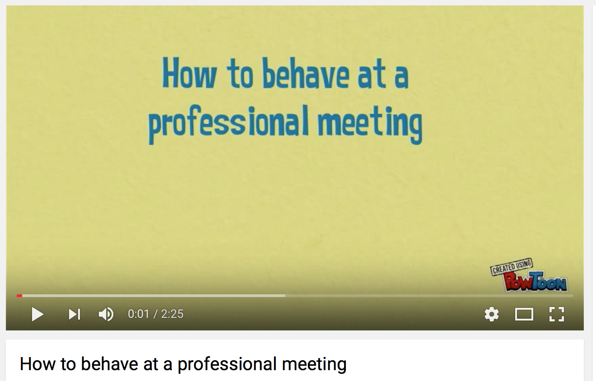

- First impressions are important
- Be prepared, knowledgeable, and professional
- Turn off your phone
- Check any papers that you are submitting for errors
- Address him/her by the correct title
- You can tell as few or as many professors as you would like to tell
- You do not have to give the details of your disability
- Share your strengths

What do you Think?

Read the following scenario. This student does four things well and makes four mistakes. Can you spot them?

Jerry walks in to the professor’s office a few minutes after their scheduled appointment. “Hi John, sorry I’m late. I do appreciate that you are willing to meet with me.” Jerry looks for his list of questions for Dr. Bagel that he wrote up before the meeting. He opens his notebook and his papers fall on the floor. He then looks in his textbook and finds the folded paper. Then Jerry’s cell phone rings. Jerry apologizes to the professor and looks to see who is calling him. Since it is Jerry’s roommate, he decides to take the quick call. After the phone call, Jerry explains to his professor that he missed class last week and he has heard from his classmates that he missed a pop quiz. Jerry asks Dr. Bagel when he can retake the quiz. Dr. Bagel informs Jerry that he does not let students make up pop quizzes and will have to accept the zero as his quiz grade. Jerry then asks if he missed anything else important that day. Dr. Bagel informs him that all of his lectures are important and should not be missed. Before Jerry leaves, Dr. Bagel tells Jerry that after he gets the missed class notes from a classmate and reads the related chapter, to come back to his office if he has any specific questions about the material, as he’d be happy to clarify the information. Jerry thanks the professor for his help and leaves saying “I am really enjoying your class.”

You can find more information by visiting:
http://www.going-to-college.org/campuslife/sharing.html
Parents Chime In

Your child can start practicing these behaviors with other adults, including you, now. In everyday conversations, start bringing these behaviors to light. Set up opportunities for practice. Then point out what your child is doing well, and practice on the areas that are weak.

Wrapping Up
How do you feel now? You know the general process for disclosing your disability and receiving accommodations, you know your role in the process, and you’ve started to learn how to act in a professional meeting. Remember that all colleges are a little different in the process, the forms, and the requirements. Take the time to visit the website of a college that is interesting to you. See if you can find out information about how to receive accommodations at that school!
For More Information…Digging Deeper

Going to College
http://www.going-to-college.org

Business Meeting Etiquette
https://www.youtube.com/watch?v=15Av0DLUQNk

Accommodations for College Students
http://www.wrightslaw.com/info/sec504.college.accoms.brown.htm
Have you accomplished today’s objective?
You will
- Put the steps for receiving accommodations in college in order and tell who is responsible for initiating each step.
- Show how to hold a professional meeting while clearly talking about a disability and the accommodations you need.
If not, review the information on how to self-disclose in college again. Have your parent/guardian review this with you.

