**Module 2 Part 4 – Internet Safety**

*This section corresponds with middle school transition classroom materials from Module 2 Activity 1.*

**Introduction**

**Objective:** You will identify dangers of internet use and write two ways to increase your personal safety online.

**Estimated time needed:** 30-45 minutes

**Additional materials needed:**

* Internet access
* Poster making materials
  + Paper, markers, etc.
* Pencil and paper

**Introduction**

**Learn About It**

**Good Things about the Internet**

**Dangers of the Internet**

**Internet Exposure**

**Video Time**

**Tips for Staying Safe**

**Your Turn**

**Wrapping up**

**Objective Check**

**Digging Deeper**

**Introductory Video**

*[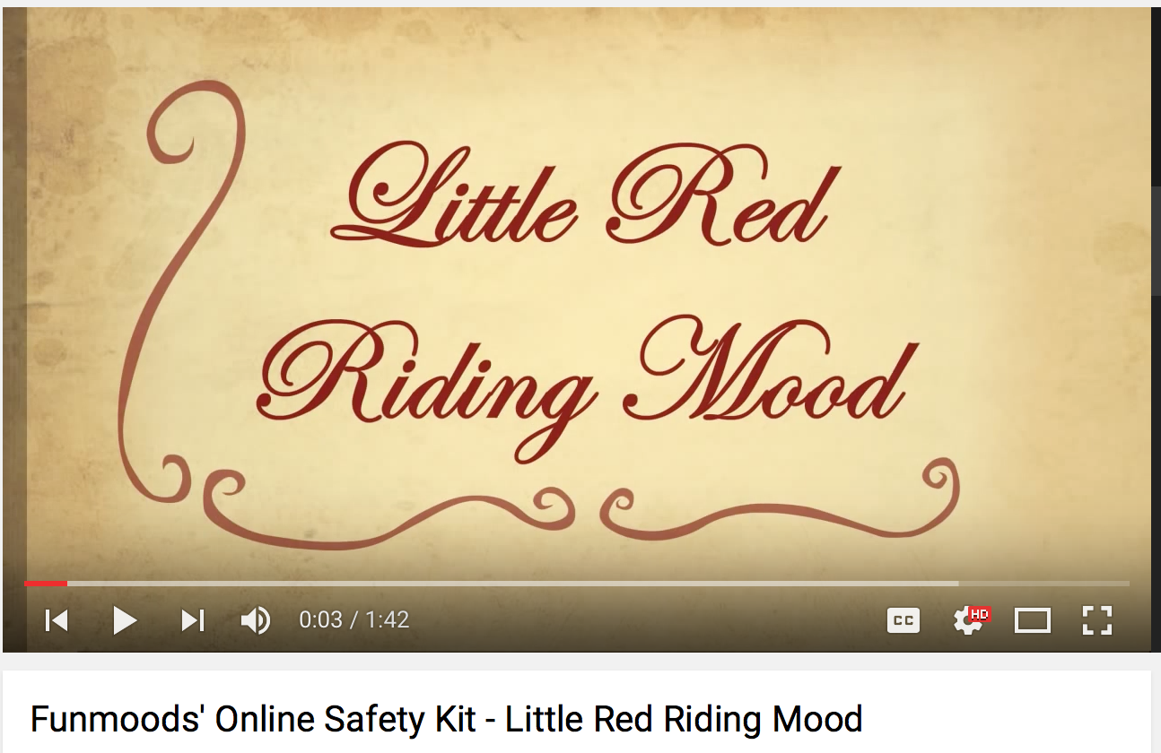](https://www.youtube.com/watch?v=KGr_KFiCX4s&list=PLpwc2HfgoAyJ89WEasZ3XugzyoJ7iDSDR&index=2)*

**Learn About It**

If you remember the story of Little Red Riding Hood, you know that there was a wolf who makes a plan to eat a little girl. By disguising himself, he is able to get close to her. Unfortunately, this is happening all of the time today. No, there isn’t an actual wolf who is stalking little girls in a red cape, but there are people who are trying to get close to and hurt young people today by pretending to be someone that they aren’t on the internet. Today you are going to see that this is a very real threat, and that you could be in danger without even knowing it. The good news is that you can do something about it! You can stay safe and use the internet at the same time.

**Parents Chime In**

When you were growing up, you didn’t have to be concerned about online threats, but it is a very real danger today. It is important that you become aware of the dangers and then have open and honest conversations with your child about internet use and staying safe. It is vitally important that you know how your child is using the internet and ensure that the correct security measures are in place.

**Good Things about the Internet**

The internet is an amazing thing, and while it seems like it has been here forever, it is relatively new. Most of your teachers, parents, and other adults in your life did not grow up online. Because you have always had access to the internet, you might take for granted some of the things that it allows you to do. Not only do you have unlimited access to information, but you can watch amazing things that people never saw in the past. Video footage of rare animals, exotic places, human feats, music, art, and social events that will mark history are all things that you are used to seeing. When used correctly, the internet is an invaluable resource, and it is fun! The problem is that there are a lot of dangers that are easily overlooked.

**Dangers of the Internet**

While there are many good things that come from the internet, there are many dangers that come with it as well. Unfortunately, there are people who use the freedom of the internet to harm others. Let’s look at a few ways that people can be harmed by internet use.

* **Cyberbullying**: Bullying looks different when it is done online, but it is still just as hurtful and scary. Cyberbullying is the use of technology to harass, threaten, embarrass, or target another person. By definition, it occurs among young people. Some examples include mean or cruel posts on social media or text messages, impersonating someone online, or posting information/pictures/videos intended to hurt or embarrass someone.
* **Exposure to inappropriate material**: This can happen very quickly. While it is easy to intentionally look at things that you know are not appropriate, sometimes it happens purely by accident. One minute you could be searching for information about a research project, and the next you have a picture of something you never dreamed of seeing glaring across your screen.
* **Online predators:** This is one of the most dangerous threats to internet users. There are people who intentionally look for kids online with the hope that they can lure them into a situation that will bring them harm. This is what our video was showing at the beginning of the lesson. When you are online, you do not know who is on the other end of your communication. You don’t know if their pictures, videos, or information is authentic.
* **Theft of personal information**: You might not have bank account information or a credit card number that can be stolen, but there are people who are on the lookout to find other personal information that will cause problems in your life. This information can be found in chat rooms, email schemes, and many other ways.
* **Repercussions for personal actions**: It is a fact that people make mistakes. You wouldn’t be human if you didn’t mess up from time to time. The problem now is that most mistakes are plastered on social media either by the person who is making the mistake or the people around that person. School administrators, college acceptance boards, scholarship reviewers, and potential employers check social media sites for more information on people. Your social media sites tell more about you than you may want people to know, and your mistakes have a much greater chance of impacting your future.

Click [here](https://www.youtube.com/watch?v=ovBF0OUbmfo) for a video about dangers on the internet.

Hirsch, L. (2014, June). Cyberbullying. Retrieved from [http://kidshealth.org/en/parents/cyberbullying.html#](http://kidshealth.org/en/parents/cyberbullying.html).



**Internet Exposure**

With the internet comes the opportunity for you to be seen. This can be a very positive thing. You may start a blog or a YouTube channel. You may be able to talk to your family member that lives in another state. You may make a friend that you would have never known who makes a difference in your life. On the flip side, this exposure can be very dangerous. It makes you visible to many people, some of whom are dangerous. It is very important to stay cautious and careful when deciding what and how much to put online for all people to see.

Some of the ways that you are visible to the world through the internet include:

* Social media
* Instant messaging
* Webcams
* YouTube videos
* Blogging

**What the Stats Say**

Many studies have been done about teenagers and online activity. These are some of the statistics that have been found.

* 17% of teens say they've been contacted online by someone they didn't know in a way that made them feel scared or uncomfortable
* 30% of teens say they've received online advertising that was inappropriate for their age
* 39% of teens admitted to lying about their age to gain access to websites

Hirsch, L. (2014, August). Teaching Kids to Be Smart About Social Media. Retrieved from <http://kidshealth.org/en/parents/social-media-smarts.html?WT.ac=p-ra>.



**Video Time**

Sometimes it is easy to hear the facts, but they don’t quite sink in. It may seem like it would never happen to you. NetSmartz is a website full of information about internet safety. Take some time now to go to the website and watch a few of the videos on the dangers of internet use. They give real life examples of what could happen. Click [here](http://www.netsmartz.org/NSTeens) to access website.

After you have watched a few videos, choose one and get creative. Create a poster, commercial, or electronic presentation that tells others what you have learned. Make sure that you include

* The problem portrayed in the video
* Warning signs that would alert the person to danger
* A solution to the problem

When you are finished, present your product to someone like a parent, friend,

teacher, or sibling.

**Parents Chime In**

You have probably seen or heard of stories where teens have been hurt by their online activities. Perhaps you’ve taken it seriously, or perhaps you’ve thought that your child is careful and it wouldn’t happen to him/her. As you can see from the statistics above, it happens to many children. The threats online are real. While you don’t need to ban your child from ever using the internet again, it is important to be knowledgeable of the threats and aware of your child’s activities.

Part of being knowledgeable is knowing the acronyms used in texts or chat rooms. There are many sites with information about this. Due to the ever changing nature of these acronyms, you will need to stay up to date.

<http://www.cnn.com/2014/12/08/living/internet-acronyms-every-parent-should-know/> (May 26, 2016)

<http://www.netlingo.com/top50/acronyms-for-parents.php> (May 26, 2016)

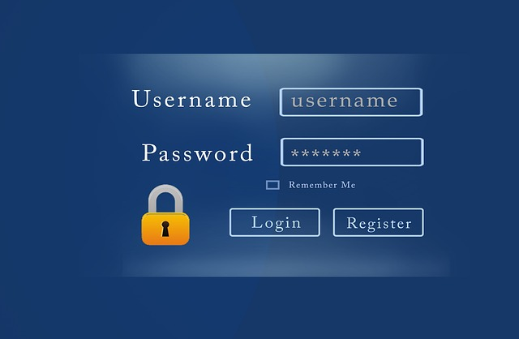

**Tips for Staying Safe**

The internet is not a terrible threat that you should never get near. However, you do need to be wise when you are using it. There are ways to stay safe and still take advantage of all of the benefits of being online. Many of these were discussed in the videos, but this is a good list to get you started.

* Set strong passwords
* Set your privacy settings
* Limit your friends
* Don’t show your location or check in
* Never meet online friends in person
* Think before you post words, actions, or pictures
* Talk openly to parents or trusted adults
* Be aware! Not everyone is good, and it’s hard to make that distinction online!

Click [here](https://www.youtube.com/watch?v=yrln8nyVBLU) for a video with more information on staying safe online.



**Your Turn**

You’ve taken in a lot of information today, but it doesn’t do you any good unless you can apply it to your life. Think through these three questions, and write your answers down. If you need some guidance, you can use the handout below to help you organize your thoughts.

* List the ways you use the internet.
* How are you keeping yourself safe?
* What else do you need to do to stay safe?

Click here to access the Internet Safety Handout.

**Wrapping Up**

The internet is an amazing tool that has transformed the way we live. We have more access to information and other people than ever before in history. While it is great, it still needs to be respected. Hopefully today you have learned how to keep yourself safe, and you will make good decisions about internet usage as you go through high school.

**Have you accomplished today’s objective?**

You will identify dangers of internet use and write two ways to increase your personal safety online.

*If so, congratulations!*

*If not, review the information on internet safety again. Have your parent/guardian review this with you.*

**For More Information…Digging Deeper**

Top Ten video rules

<https://www.youtube.com/watch?v=45CEKL_C9m8&list=PLpwc2HfgoAyJ89WEasZ3XugzyoJ7iDSDR>

NetSmartz Workshop

<http://www.netsmartz.org/Parents>

Kids Health

<http://kidshealth.org/en/parents/net-safety.html>

National Crime Prevention Council

<https://www.ncpc.org/topics/internet-safety>