**Module 2 Part 3 – Technology in the Classroom**

*This section corresponds with middle school transition classroom materials for Module 2 Lesson* 3.

**Introduction**

**Objective:** **(1)** You will identify two types of technology and two mobile apps that are useful in academic settings for students with different learning styles. **(2)** You will identify two types of technology that would benefit you personally and justify why.

**Estimated time needed:** 30-45 minutes

**Additional materials needed:**

* Internet access
* Paper and pencil

**Introduction**

**Learn About It**

**Types of Technology**

**Assistive Technology**

**Reasons for AT**

**Ranges for AT**

**Low Tech AT**

**Medium Tech AT**

**High Tech AT**

**Examples of AT**

**What else is out there?**

**Objective Check**

**Digging Deeper**

**Introductory Video**

*[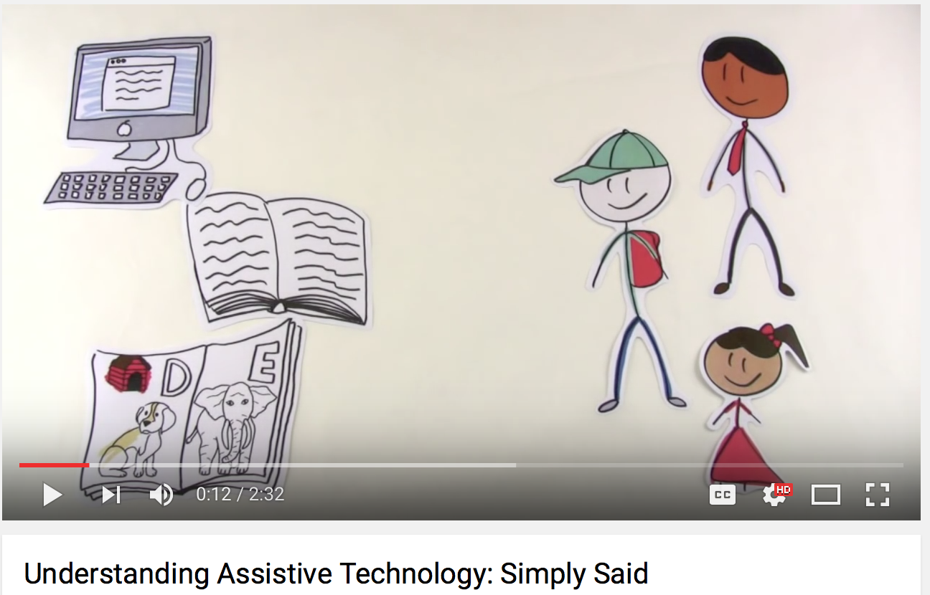](https://www.youtube.com/watch?v=DB9pKkZoJDc)*

**Types of Technology**

When we talk about technology, we are using a very broad term. We could be referring to anything from headphones to a smart board to a computer. Let’s get a little more specific so that we can start talking about the right kind of technology that will help you learn. There are three main categories of technology.

* **General**: includes all types of technology
* **Information/Instructional**: includes types of technology that help teach skills or content. It refers to anything related to computing technology, such as
  + Networking
  + Hardware
  + Software
  + the Internet
  + The people that work with these technologies.
* **Assistive**: includes types of technology that help increase functional capabilities

Today we are going to focus on assistive technology.

**Learn About It**

There is a huge difference between your childhood and your parents’ childhood. The biggest change over the last few decades is TECHNOLOGY! When your parents were children, there were no cell phones, laptops, or tablets. In fact, most of what you use every day was either just being invented or hadn’t been invented yet. Technology advancements have grown by leaps and bounds and completely changed the face of learning. Thankfully, you now have many devices that can help you overcome things that keep you from learning easily. Today you’re going to explore some of those devices and find out which ones are best for you.

**Parents Chime In**

The changes in technology are amazing! It’s sometimes hard to keep up with the latest and greatest developments. There is a good chance that your child is enthralled with tablets, gaming centers, and technology of any kind. While it can sometimes be frustrating that children have tunnel vision when they are using technology, there are many great new devices that can make your child’s learning process easier than ever. Before you go any further in the lesson, take a few minutes to tell your child what big technology you had as a child.

**Assistive Technology**

According to the federal definition of assistive technology, it is anything that will help **increase the function** of an individual. This basically just means that it is anything that will help you do something better or easier. It should

* help you to be less tired
* help your activities take less time and physical effort
* help you to use better form so that you have better performance.

Can you think of any areas where you need to “increase your function?” If so, there is a tool that has been invented that can help you. That tool that helps you “increase your function” is called assistive technology.

Click [here](https://www.youtube.com/watch?v=6IhPkaH0mqE) to watch a video about assistive technology.

**Reasons for Assistive Technology**

There are many different types of assistive technology today that meet all of the different needs of people. It is important to remember that assistive technology doesn’t make learning disabilities go away, it simply provides support for an area of weakness in order to improve learning or functionality. Also, assistive technology does not replace good study habits or good teaching. It isn’t a magic wand; you still need to work hard in order to succeed.

So what are some reasons to use assistive technology?

* Improve comprehension
* Help with memory
* Assist with organization
* Improve note taking
* Support reading skills
* Strengthen attention
* Give structure to math problems

**Ranges of Assistive Technology**

Think about the technology you use. There are the things your parents can use easily and the things that you have to show them how to use! That’s a joke, but you know that some things you use are very simple and there are other things that are very complicated. As with all technology, there is a range in assistive technology as well. Assistive technology can be categorized as

* Low Tech
* Medium Tech
* High Tech

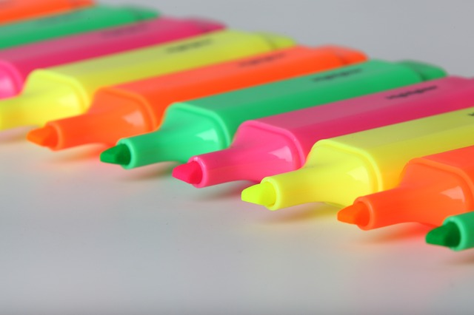

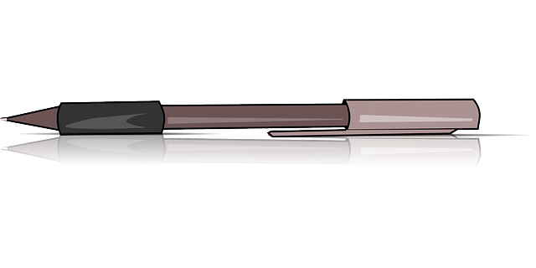





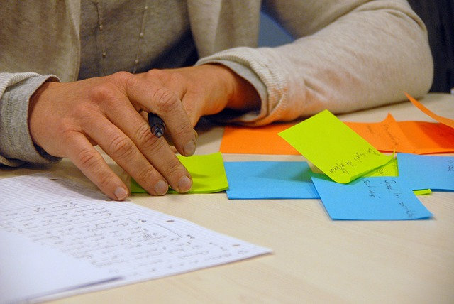

**Low Tech Assistive Technology**

|  |  |
| --- | --- |
| **Overview** | **Examples**  Hand held magnifiers  Colored paper overlays  Egg timers  Pen and pencil grips  Highlighters  Post it notes |
| Does not require much training |
| Typically are not expensive |
| Don’t have a computerized component  (Yes you read this correctly. Technology does not have to be computerized! |
|  |
|  |
|  |

**Medium Tech Assistive Technology**

It often seems like almost everyone has a mobile device of some sort. There are mobile apps for practically everything people might need, such as:

* Organization
* Reading
* Writing
* Math
* time management

Think about some of the apps that you use now that help you with your education.

*Medium tech assistive technology*

|  |  |
| --- | --- |
| **Overview** | **Examples** |
| Might require some training | Audio books |
| Might have some technical features | Apps for mobile devices |
| Might be battery operated | Text readers |
| Might be more expensive | Speech to text devices |
| Many people use this type of AT | Alternate mouse or keyboard |
|  | Amplifiers |

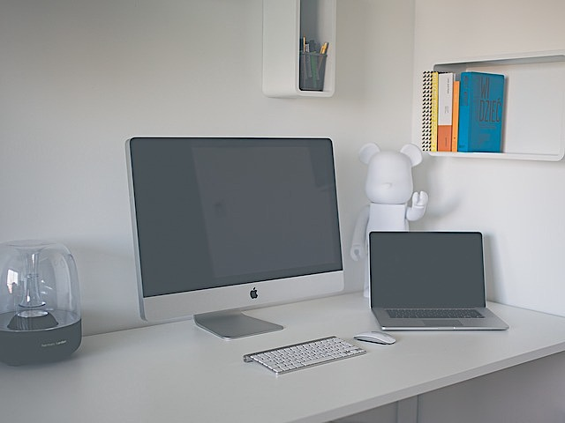



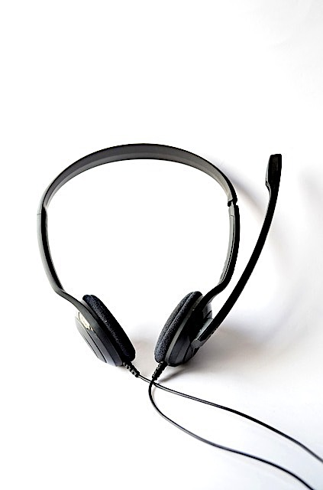

**High Tech Assistive Technology**

|  |  |
| --- | --- |
| **Overview** | **Examples** |
| More complex devices and equipment | Computers with specialized software |
| Requires training for use | Voice activated devices |
| More expensive | Blue tooth integration |
| Typically computerized | Smart pens |
| More specialized |  |
| Used by a small percentage of people |  |

**Parents Chime In**

There’s no doubt that technology has changed the way that we live and do things. The great thing, is that it has also changed the way that people learn. Talk to your child and brainstorm a list of things that are hard in an academic setting. These can be based off of an IEP, a learning styles test, or just observation. Then think through what supports in terms of technology are already in place for your child. Take some time to evaluate if it is working or not. If you need help with formatting these thoughts, use the link to get to a form that will help you. When you use this form, don’t worry about the last column yet. We’ll get to more examples of assistive technology later.

Click here for the Assistive Technology I Use and Need form

**Examples of Assistive Technology**

You’ve read examples of from each type of assistive technology: low, medium, and high tech. You probably have a good understanding of the low and medium assistive technology, but it’s sometimes hard to imagine what the high tech assistive technology looks like. Watch these videos that show assistive technology at work. Create two circle maps that you will use while watching the videos. Write down information about these products while you are watching. What does the product do? What is interesting about it? If you want to print out circle maps instead of creating your own, use the link below.

Click here to access circle maps for videos.

The first product is the Smartpen from Livescribe. This is a ballpoint pen with embedded digital audio recorder that synchronizes written notes on special paper with audio recording. Click on the image to watch the video.

[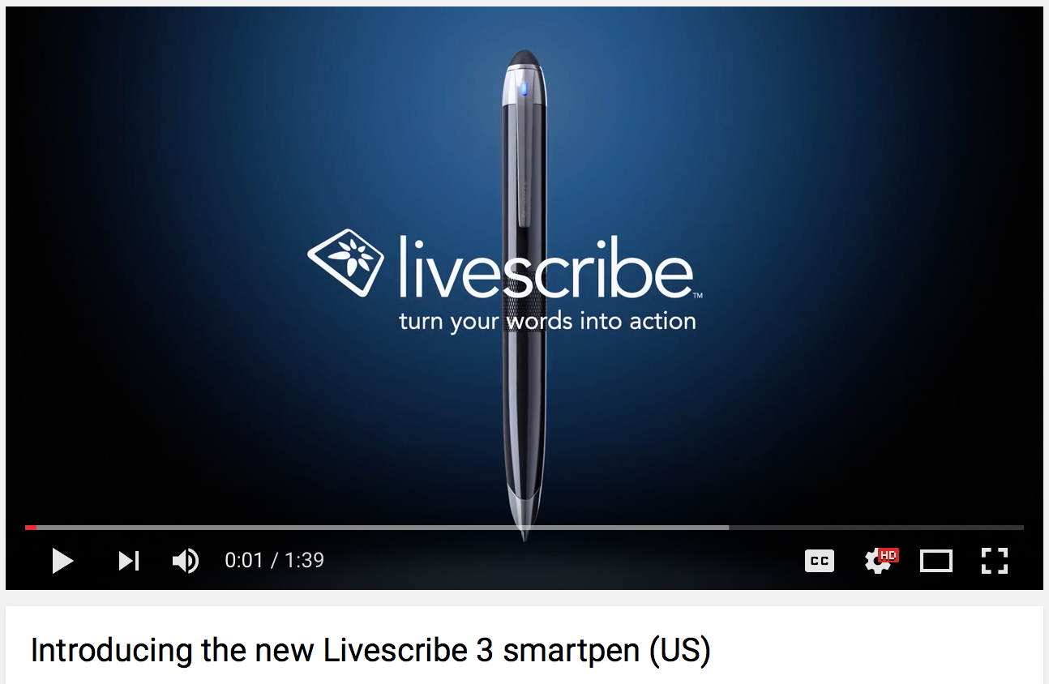](https://www.youtube.com/watch?v=TFE74S40WoI)

The second product is Dragon Naturally Speaking. It is a speech-to-text software that the student installs on the computer. The program converts speech into text, allows for voice commands of the computer, searching the internet, etc. Click on the image below to watch the video.

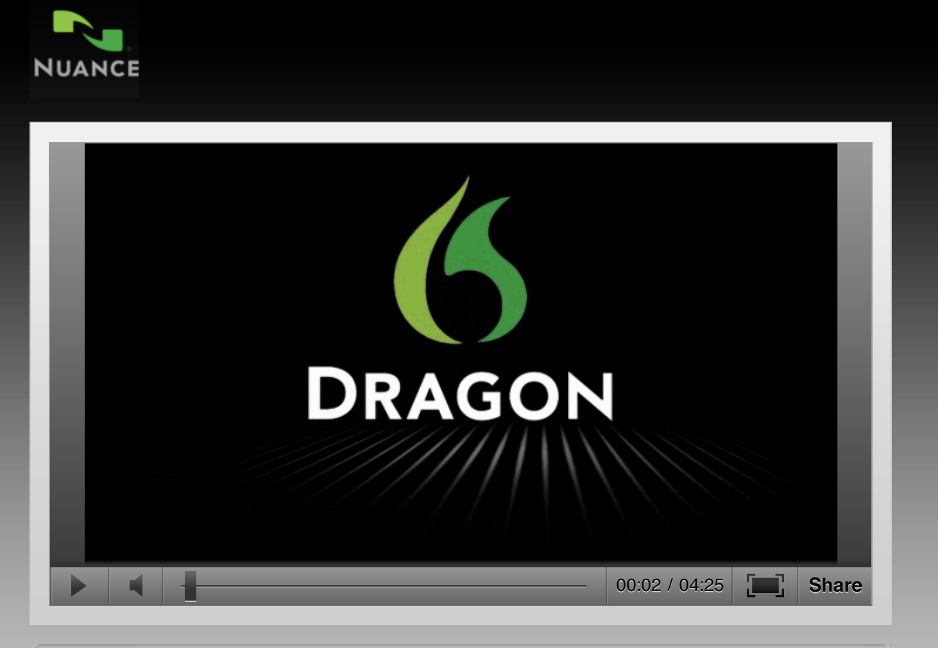

As you can see from these videos, these are examples of high tech assistive technology. Some training would definitely be necessary in order to use these devices effectively. This is called a learning curve. This technology wouldn’t help you until you learned how to use it effectively.

**[](https://www.youtube.com/watch?v=pL8TLPcsyOs)**

The third product a text-to-speech software. Students can use this kind of software to hear text materials (such as textbooks, trade books, news, articles, web pages, etc.) read aloud. The version of text-to-speech software featured here is called *Read Write*, but there are many different brands/versions of this kind of resource ranging from some that are free to those that are very expensive.  Click on the image to watch a

video about Read & Write GOLD v. 11

**What else is out there?**

There are many tools available that can help you. It’s your turn to take a look and see what you can find. Search around and see what you can find. Of course you can use the internet, but you can also call your local school system. They should have a department that is solely in charge of assistive technology. There are links below to internet sites that have good examples of assistive technology if you need some help getting started. While you are researching, try to find the following information:

* Examples of mid-range assistive technology
* 2 apps for mobile devices
* 2 actual devices or software for a device

Record your information on a circle map. Remember, don’t just choose the first one you find. Look around and see what is out there.

When you are finished, look back at the brainstorming you did with your parent/guardian about your learning challenges and the assistive technology you currently use to help. Did you find anything else that would be more helpful? Make sure that you are able to tell why the assistive technology would help you. You will need to be able to articulate this in the future, so it is good to start practicing now!

Use the Assistive Technology and Me handout to help you clearly write what you need.

Click here for handout.

**Wrapping Up**

You have looked at all sorts of assistive technology today. Did you see anything you liked or something that you had never seen before? The good news is that new things are being developed all of the time. The assistive technology can make a huge difference in your ability to learn and perform, but remember, it does not take the place of good study habits!

Assistive technology is not only available to you now, but it can be very useful in college. Click here to see real examples of how college students have used assistive technology to help them be successful in college.

Click here to access How I Use AT document.

**Have you accomplished today’s objective?**

**(1)** You will identify two types of technology and two mobile apps that are useful in academic settings for students with different learning styles. **(2)** You will identify two types of technology that would benefit you personally and justify why.

*If so, congratulations!*

*If not, review the information on assistive technology again. Have your parent/guardian review this with you.*

**For More Information…Digging Deeper**

Click here for a review of digital pens.

Click here for a List of mobile apps

Assistive technology basics

<https://www.understood.org/en/school-learning/assistive-technology/assistive-technologies-basics>

Guide to Assistive and Accessible Technologies

<https://www.disability.gov/resource/disability-govs-guide-assistive-technology/>

Understood: For Learning and Attention Issues

<https://www.understood.org/en/school-learning/assistive-technology/finding-an-assistive-technology/6-new-apps-for-tweens-and-teens-with-learning-and-attention-issues>

Reading Rockets

<http://www.readingrockets.org/article/assistive-technology-kids-learning-disabilities-overview>

Citations:

<http://www.gatfl.org/assistive.php> (March 6, 2016)

*Updated May, 2016*