**Module 2 Part 2 – Navigating the ITP Process**

*This section corresponds with middle school transition classroom materials from Module 1 Lesson* 2.

**Introduction**

**Learn About It**

**Setting Goals**

**What’s an ITP?**

**Transition Planning**

**Transition Meeting Preparation**

**Things To Do at Your Transition Meeting**

**College**

**Follow up**

**Objective Check**

**Digging Deeper**

**Introduction**

**Objective:** You will list at least 4 people who should be involved and at least 2 things that should be considered during your upcoming transition planning meeting.

**Estimated time needed:** 30-45 minutes

**Additional materials needed:**

* Internet access
* Current copy of your IEP
* Printed copy of the goals flow map found online

**Introductory Video**

: [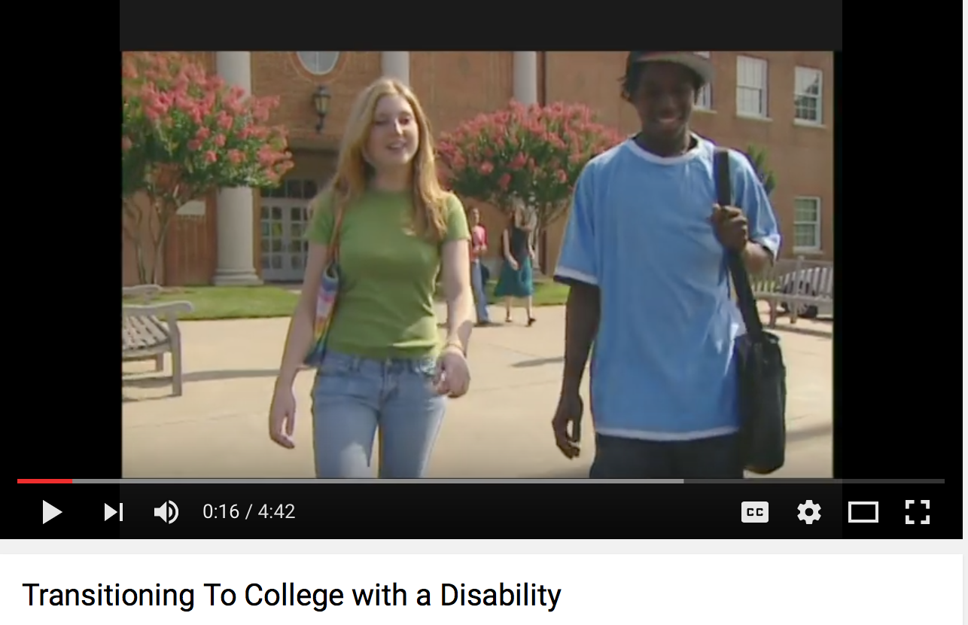](https://www.youtube.com/watch?v=qb7jBbp-EXE)

**Learn About It**

IEP, ITP, IDEA…how many acronyms are out there when it comes to the support for your learning? The titles alone can be overwhelming! By this stage in your life, you should be comfortable with your understanding of an IEP, but you probably haven’t heard much about your ITP. It is also referred to as simply ***transition planning.*** This is really just a formal name for getting ready for the next stage of your life. Right now, the next stage of your life is high school, but the law says that by the time you are 16, you need to start thinking about your life after high school. The procedures in NC encourage you to start the process by the time you are 14, and that is right around the corner. So let’s dive in and find out about your ITP!

If you’ve gone through these lessons step by step, you understand the importance of setting goals. You may have even completed a goal setting activity already. You can use this form to revisit your goals. If you haven’t set goals before, this flow map with give you some structure to think about one academic goal and one career goal. You’ll want to list the goal first and then back track to think about the steps that you’ll need to take to get there. Spend some quality time thinking about your goals. After all, you have to know where you’re going in order to create any sort of transition plan!

Click here to access flow map.

**Setting Goals**



**Parents Chime In**

Parents, it’s natural for you to have goals for your child. You’ve had goals in mind from the moment he/she was born! While you have the perspective of years of experience and seeing your child’s strengths and weaknesses, now is the time to begin letting your child think for himself/herself. You’ll certainly want to guide the goal setting process, but also consider stepping back a little and listening to your child’s personal goals. They might line up with your goals, but they might also be different. Remember, your child is still young. The goals set today might change many times over the course of the next four years, but setting a good foundation for planning for the future is of the utmost importance. Have fun dreaming of what is to come!

**What is an ITP?**

ITP stands for your Individual Transition Plan, and its purpose is to prepare you for life after high school. This document is written by a team of people that outlines the training and support that you will need to live, work, and participate in the community as an adult. Your needs will be different from anyone else’s and will require different support because you are unique!

The same people who are always involved in IEP planning are a part of this discussion as well. That said, ITP teams can be larger. As you start thinking about your goals after high school, start inviting people who are knowledgeable about that career or school setting to your annual meetings. The people that you invite can change over time as you become more sure of what your plans are after high school. Just because you invite someone to a meeting one time doesn’t mean that he/she has to come for the rest of your high school career.

For example, if you plan to attend college, a disability support service provider and/or advisor from that college could join the meeting in person or by phone/videoconference. Another example of a new team member might be someone who works in a particular field where you want to work in the future. That person can describe things you can begin doing in order to be ready for that career as well as the education that will be needed. This is great information for the transition plan.

Other examples of team members (in addition to the regular IEP team include):

* Guidance counselor
* Transition coordinator
* Vocational counselor
* Job coach
* Employer
* Adult service representatives
* Anyone who knows you well such as friends or relatives



**Parents Chime In**

Help your child brainstorm people who would be helpful to his/her transition team based on your understanding of your child’s academic and career goals. Many times middle school students aren’t aware of the different jobs and roles that people play beyond teacher and guidance counselor. If you don’t know someone personally that could help, ask your friends or co-workers or contact the guidance counselor at your child’s school. There are many people who can help!



According to IDEA (Individuals with Disabilities Act) 2004: Transition Services for Education, Work, Independent Living, the term ‘transition services’ means a coordinated set of activities for a child with a disability that

* is designed to be a ***results-oriented process*** that is focused on ***improving the academic and functional achievement*** of the child with a disability to facilitate the child's movement from ***school to post-school activities***, including post-secondary education, vocational education, integrated employment (including supported employment), continuing and adult education, adult services, independent living, or community participation
* is based on the ***individual child’s needs***, taking into account the child's strengths, preferences, and interests

Well, that’s a mouthful of words, so let’s break it down.

* It doesn’t need to be something that just looks good on paper. It should be something that you will actually use.
* It’s going to help you take the step from high school into the next stage of your life.
* The stage of life after high school is going to look different for everyone and should be centered around your interests and goals. Examples of those might be:
  + Post-secondary education (college)
  + Vocational training
  + Employment
  + Adult services
  + Living arrangements
  + Community participation
* It is based on YOUR needs.

Remember

You should be involved

You should have a voice

Set goals that aim high *and* are realistic!

**What does transition planning include?**



An interest inventory is a self-assessment tool, used in career planning, that assesses your likes and dislikes of a variety of activities, objects, and types of persons. The idea is that people in similar careers have similar interests.

For example: What do you want to do when you graduate from high school? Have you always wanted to be a nurse’s aide or a preschool teacher? Or, are you not sure? One thing that might help you decide the type of work you would enjoy is to consider your interests. Did an activity allow you to use or develop your skills or strengths or learn something new? Was a hobby or an activity fun because you were with people or did you like the environment (outdoor activity versus indoor)? Did you enjoy a movie or book because it was one of your favorite topics and if so, what do you like about that topic? Begin by thinking about what experiences you enjoy and why you enjoy these experiences.

Now is a good time to write down your strengths, weaknesses, and goals for the future. This will help you get ready to speak up and ask questions during your transition meeting.

Click [here](https://www.mynextmove.org/explore/ip) to explore careers that may be right for you.

Let’s think logistically and make a list of things you can do to help you get ready for your Transition Planning Meeting!

* Review your IEP from the previous year (if you have one).
* Talk with your teacher and parents so that you’ll know what to expect at the meeting.
* Write down any questions that you want to ask the team.
* Ask who will be attending the meeting so you will be prepared.
* Ask for help in preparing for your meeting. Set up an appointment to meet and practice for the meeting!
* Make sure to ask questions!

**Preparation for Your Transition Meeting**

The time has arrived and you are finally ready for this long awaited meeting. You’ve set goals, carefully thought about your interests, and done all of the prep work, so what now. What will actually happen at your Transition Meeting?

* You will share your interest inventories
* You will talk about the things you want to do after high school
* You will ask questions
* You or someone else will take notes
* You will need to ask for clarification if you don’t understand something
* You will be positive! The people in the room are there for you and they want to know what you think!

As you can see, your job is to know about you. There will be experts in the room that are very familiar with the process, the forms, and the logistics of the meeting. Let them take care of that. You just need to be ready to share about yourself. And one more thing, the people in the meeting might be experts, but if you don’t agree with something, speak up! This is your future!

**Things to Do at Your Transition Meeting**

**College**



College can seem like a huge dream that is a million miles away. Have you ever thought about going? Have you ever thought that there is no way that you could handle it? Things work differently after you leave high school, but there are supports available! Make sure you talk about college at your transition meeting!

It is extremely important for you and your parents to understand your state’s requirements for graduation from high school. The course of study selected in high school will depend on your abilities and interests. You may follow a course of study that leads to a high school diploma or a graduation certificate. Bear in mind that, even with a diploma, you may be ineligible for admission to a technical school or college without the requirements of algebra or foreign language courses.



**Follow Up**

Well, how do you feel? Can you talk to your parent/guardian about the following things?

* The basics of a transition meeting.
* Your goals.
* Your interests.
* What you will do to prepare for the transition meeting.

**Parents Chime In**

Before you go to the meeting, you may want to talk to a parent who has been through the process before. This will give you good perspective on what to expect and how you can prepare. If you don’t know anyone else who has a child with disabilities, ask around. Your school’s guidance counselor won’t be able to give you the name of someone else, but he/she can give your name to another parent and have that person contact you!

**Have you accomplished today’s objective?**

**Objective:** You will list at least 4 people who should be involved and at least 2 things that should be considered during your upcoming transition planning meeting.

*If so, congratulations!*

*If not, review ITP examples again and discuss the questions at the end of this lesson. Have your parent review this with you.*

**For more information…Digging Deeper:**

Why a Transition Plan

<https://www.autismspeaks.org/family-services/tool-kits/transition-tool-kit/why-transition-plan>

Durham Public Schools: Post Secondary Transition

<http://www.dpsnc.net/pages/Durham_Public_Schools/Parent_Resources/CIA/Exceptional_Children/Post-secondary_Transition>

Individual Transition Plans (ITP)

<http://cms.zcs.k12.in.us/sites/default/files/uss/ITP.pdf>