**Module 1 Part 4: Understanding Myself as a Learner**

*This section corresponds with middle school transition classroom materials Module 1 Lesson 4.*

Introduction

Objective: You will describe (a) your learning strengths, (b) your learning challenges, (c) environments in which learning comes easy, and (d) environments where learning is more difficult.

Estimated time needed: 30-45 minutes

**Materials needed:**

Internet access

Handout for learning styles research

Bubble map

Red and green markers, crayons, or colored pencils

Introduction

Learn About It

My Goals

* Understand learning styles
* Recognize my learning styles

Objective Check

Digging Deeper

Introductory Video

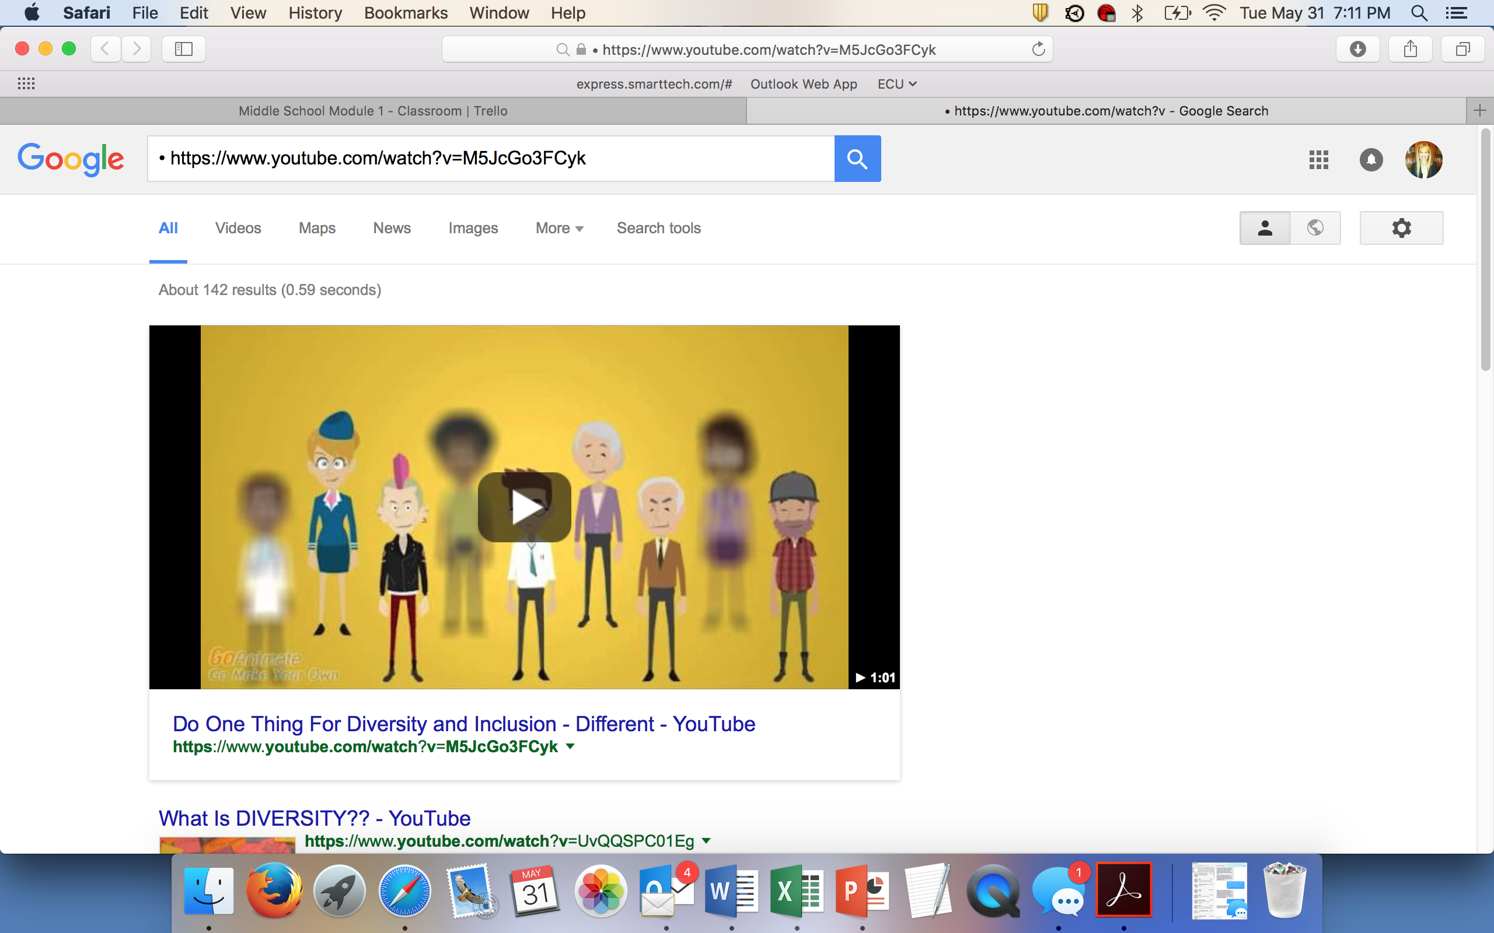

Parents Chime In

There has been a lot of research dedicated to exploring learning styles, and therefore, there are many different names and categories for them. All of the different information can be confusing for adults as well as kids. The point of this lesson is to expose your child to the fact that there are different learning styles or preferences, and then to encourage him or her to think about how he or she learns best.

Working through this information with your child can be fun. Jump in and learn how you learn best. You might be surprised by what you find!

Learn About It

Think about the people you are around every day. What do you notice? For years you’ve heard that we are all different in our looks, our personalities, and our beliefs. But our differences go even deeper than that. How our brains process information differently also makes us different in how we learn! This is generically known as having differences in our learning styles. Today we will consider the different learning styles. We will learn which ones are your strengths and which are more challenging for you. This will give you a much better understanding of how you learn.

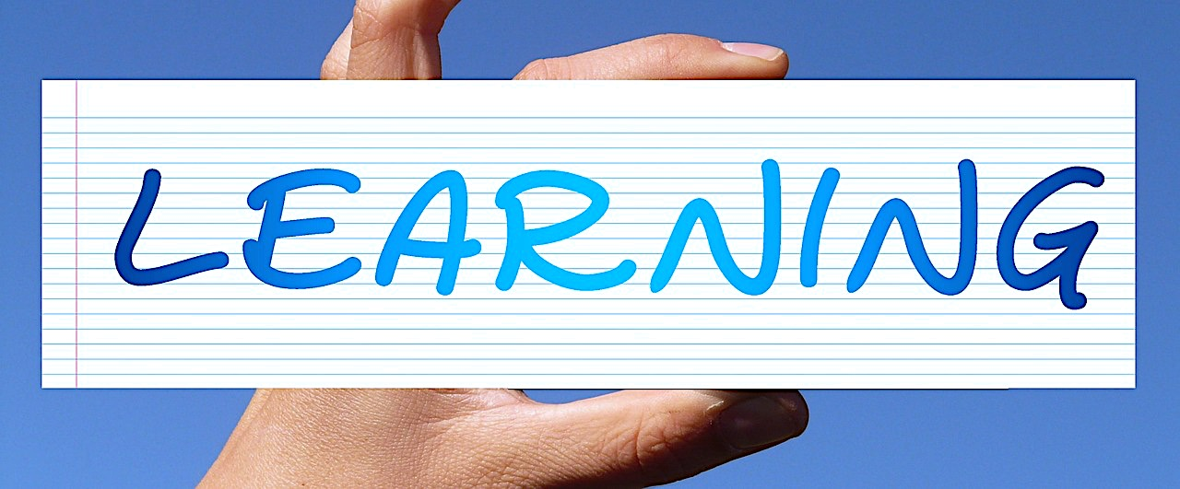



YOU

What are Learning Styles?

There are many different ways that we learn new things. When you were in kindergarten, you learned about the 5 senses, and that we learn new things through sound, smell, touch, sight, and taste. We also learn new things by interacting with people or materials or by doing new things. We all receive and respond to information and new material all day long. Simply put, a learning style or preference is the way that you handle and remember this information the most naturally.

There is a lot of research on learning styles, and many people have defined learning styles in different ways. For our purposes, we are going to highlight a few of these definitions.

Richard Felder and Linda Silverman (NC State University) describe 4 learning categories:

* + active versus reflective
  + sensing versus intuitive
  + visual versus verbal
  + sequential versus global.

Many people have adapted variations on the “Seven Learning Styles”:

* + visual (spatial)
  + aural (auditory-musical)
  + verbal (linguistic)
  + physical (kinesthetic)
  + logical (mathematical)
  + social (interpersonal)
  + solitary (intrapersonal)

You may have also heard theories based on right-brain learning versus left-brain learning.

The “Faces of Learning” approach describes learners as having a learning profile:

* + attention
  + complex thinking
  + language
  + memory
  + controlling movement
  + getting along with others
  + spatial thinking
  + keeping track of time and order.

By learning about each each type of learning style, you will be able to see the big picture of how you learn. Remember that “learning styles” simply refers to the fact that people receive and respond to information differently. Some people like to see pictures or charts, some prefer a linear list, some need to manipulate concrete materials in their hands, and some respond well when information is set to music or a beat.

Check out this video, which explains a few different learning styles in a fun way!

[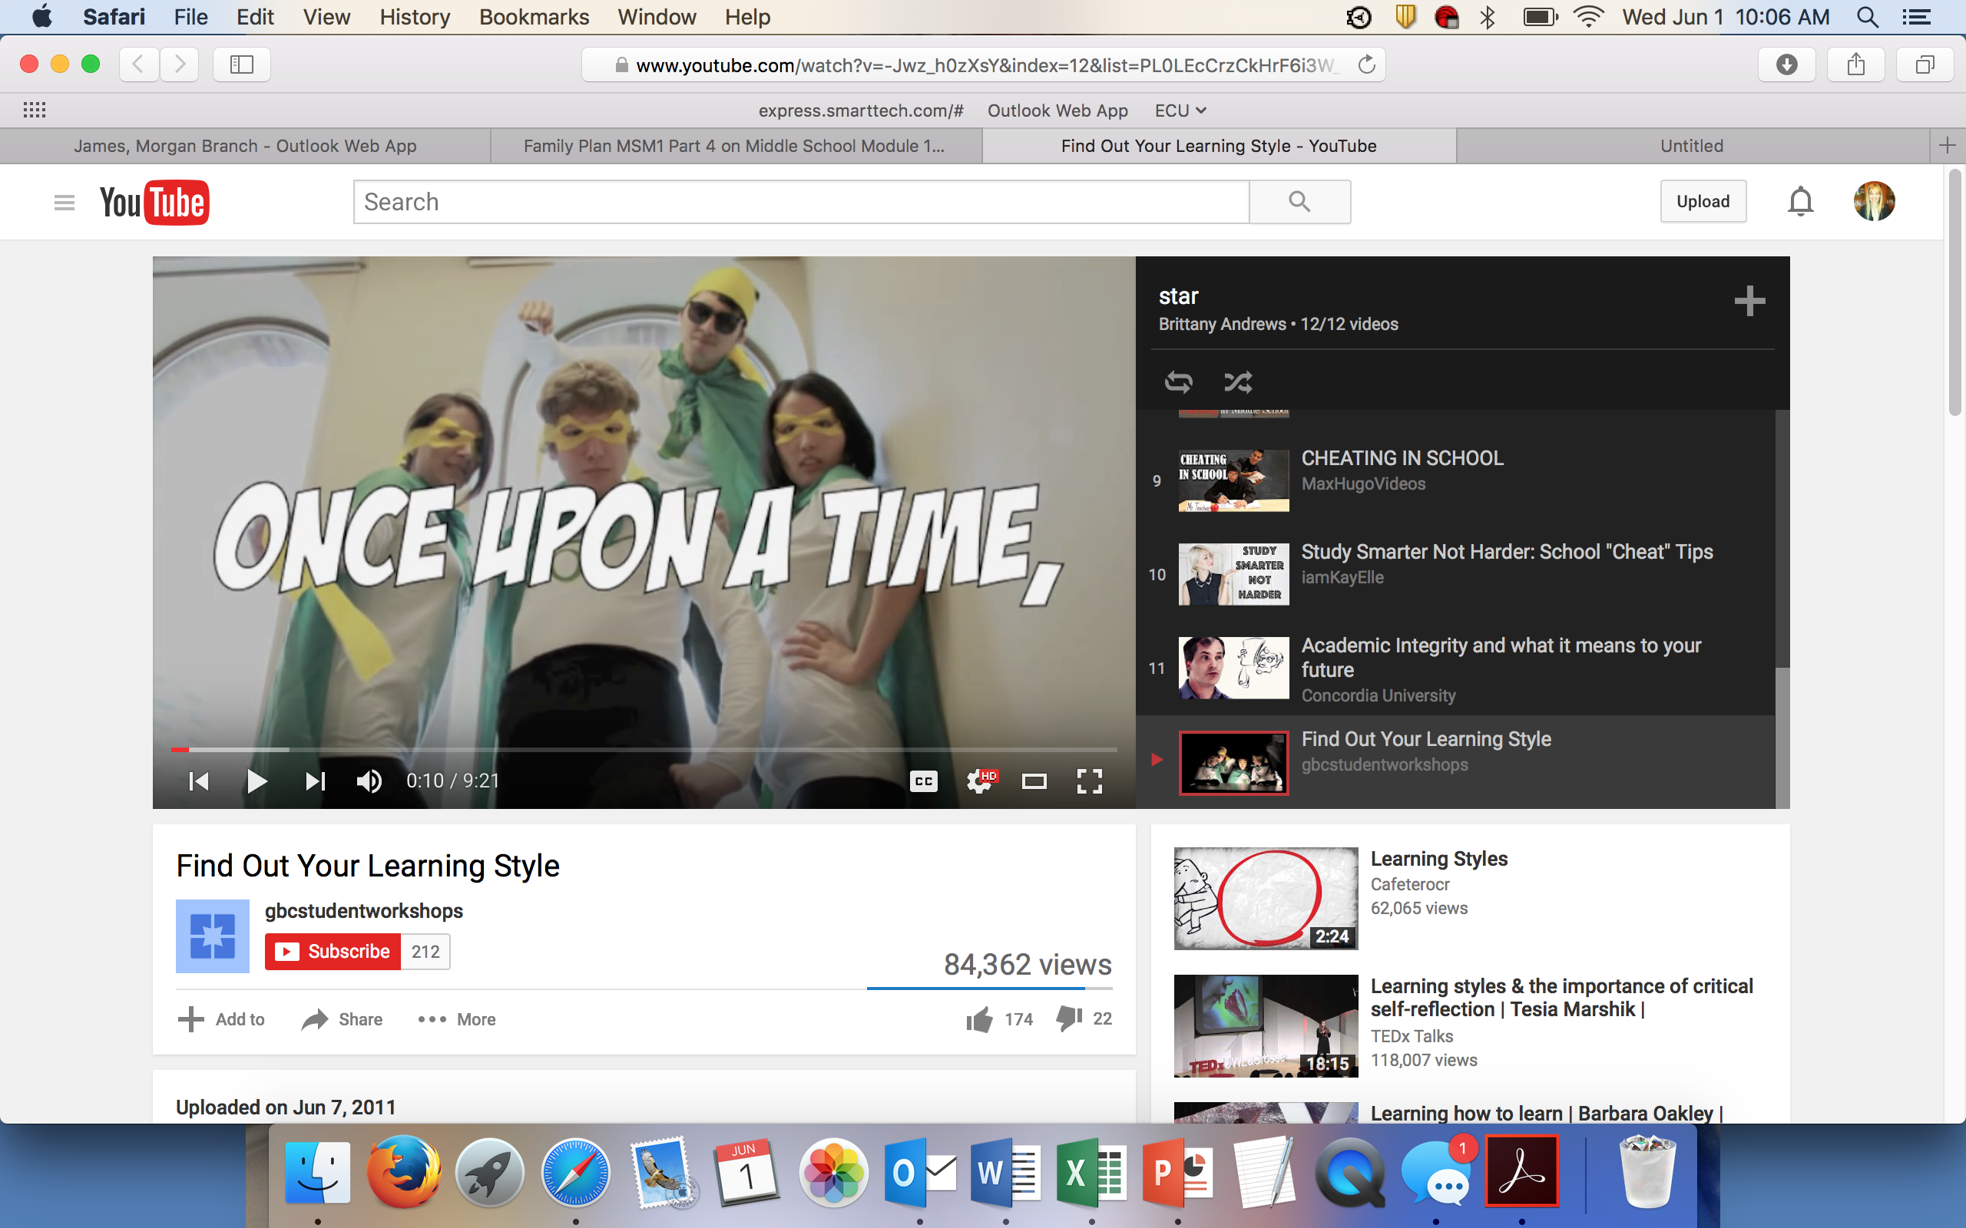](https://www.youtube.com/watch?v=-Jwz_h0zXsY&index=12&list=PL0LEcCrzCkHrF6i3W_aWQXZCTzzuGViE1)

Parents Chime In

Your child just had a brief overview of what a learning style is and why it is important to know his or hers. In the next section, your child is going to learn about different versions of learning styles in more detail. Help direct your child to one that looks interesting, not just the one that seems the simplest to research. Your child might need your help reading some of the information on the websites. Take the time to look through the material. Print out and use the research handout to help organize the material if you can. Learning this information now can make a big difference in your child’s success in high school.

Why Should I Know My Learning Style?

Knowing your learning styles gives you a better picture of your strengths and weaknesses as a learner. You don’t have just one way that you learn well and one way that you don’t learn well. Think of it more like a sliding scale from 1 to 10. You might be on the low or high end with some learning styles and in the middle with others. Not only that, but your learning styles might change. As you grow and develop, an area where you used to be weak may become strong. Knowing your strengths and weaknesses will help you prepare for situations that you may face in the classroom.

For example, if you’re a strong visual learner and a weak verbal learner and you’re in a class where the teacher gives lots of notes with few graphics, you will need to have a conference with your teacher. You may ask her to allow you to record classes or help you create a visual aid that will help you comprehend the material.

Additionally, knowing your strengths will help you know how to study and even choose the teachers and classes that best fit your learning style. The important thing to remember is that you are not defined by your learning style. If you are doing something that you love, you might not notice that it is being taught in a learning style that is weak for you. Learning styles can change, so do not let them become absolutes.

The big take-away is that we all have different profiles and preferences; one learning profile is not better than another. The better you know yourself as a learner, the better you’ll become at knowing how to study and work strategically. In other words, you will learn to work smarter, not just harder.

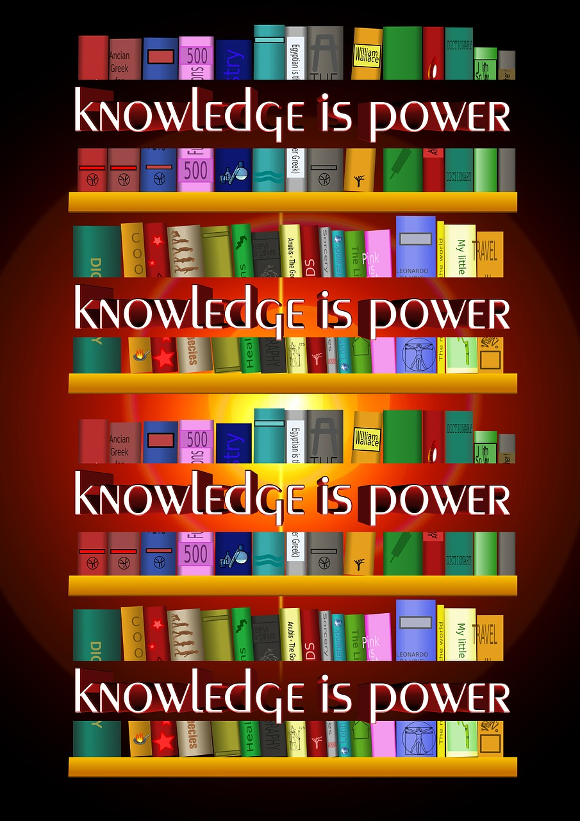

Let’s Learn More

It’s your turn to learn a little on your own. The 3 links below will give you more information and examples of the learning styles that were mentioned below. Read through the websites to learn more about exactly what a learning style is. You can research as much as you want on your own. You might find videos or graphic organizers that help you understand more about learning styles.

These links will get you started. If you only want to research one of the research perspectives we mentioned above, that is fine. If you want to research more than one, that is fine as well.

Use the handout found here to organize your thoughts if it helps you.

Felder/Silverman (Please note that this is the most challenging reading level material):  
<http://www4.ncsu.edu/unity/lockers/users/f/felder/public/Learning_Styles.html>

7 Learning Styles:  
<http://www.learndash.com/7-major-learning-styles-which-one-is-you/>

Faces of Learning: Learning profiles:  
<http://www.facesoflearning.net/questions/how-do-i-learn/science-of-learning/>

When you finish your research, see if you can explain it to someone else—a parent, grandparent, aunt or uncle, sibling, or friend.



Find Out Your Learning Style

You’ve done the research, and now it’s time for the fun! You get to take a learning styles test to find out how you learn the best.

You might want to take a test that relates to the type of profile you found most interesting (Felder/Silverman, 7 Learning Styles, or Faces of Learning). Check out the links below first. You can also take more than one of the tests to get a broader picture of your learning strengths and challenges.

Once you are finished with your tests and know your learning styles, make a bubble map that describes you as a learner. Include your personal strengths and challenges as well as learning environments that are easy or hard for you. Once you have finished, color the strengths green and the challenges red. Hang on to this bubble map, because you will use it again in part 6.



The Myth of Average

Check out this video to see how everyone is a little different and why those differences are important!

[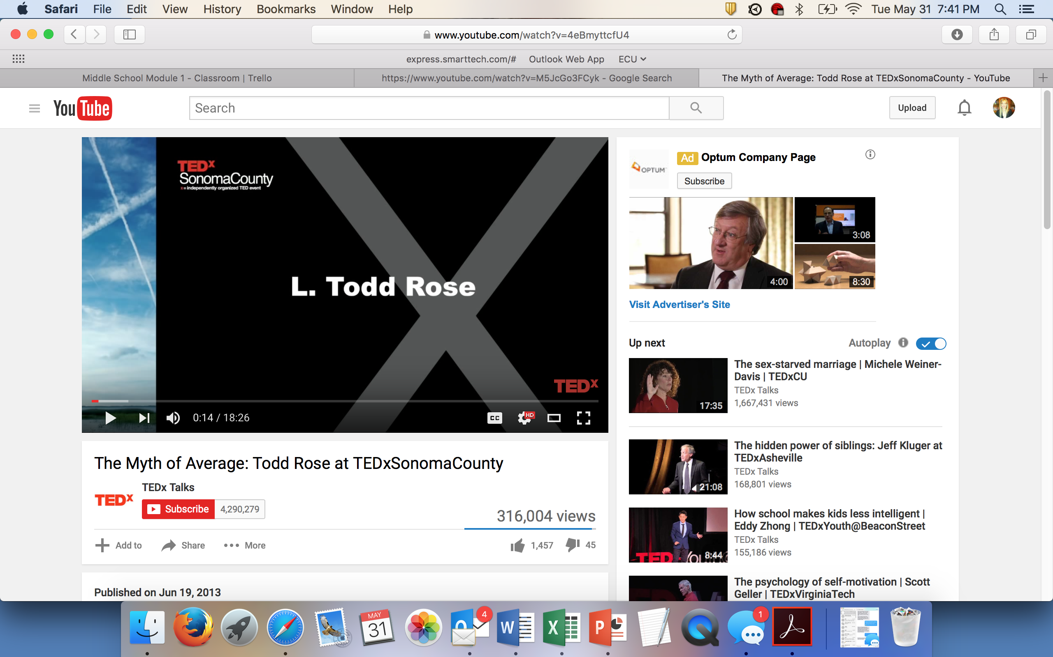](https://www.youtube.com/watch?v=4eBmyttcfU4)

**Wrapping Up**

We all learn differently, and learner variability is not a weakness. You might not show strengths in typical ways in the classroom, but you should think creatively and find “out of the box” solutions. You are no less “smart” than other students, but your brain is wired to work a little differently.

Teachers work with students who have all different kinds of learning profiles. In middle school, it is important for you to develop an understanding about how you learn best. This understanding can help you learn how to study strategically and make the most of your strengths.

It can also help you understand how to be an effective self-advocate. Students who know how they learn best and what works when accomplishing academic goals are better prepared. They know where they need support, how to talk to teachers about how they learn, and how to show what they’ve learned.

Parents Chime In

Take a test yourself…it will be fun! Compare your results to your child’s results. Was anything surprising? Did your results confirm what you already knew about yourself? It might be a fun activity for your family to complete!

Have you accomplished today’s objective?

Objective: You will describe (a) your learning strengths, (b) your learning challenges, (c) environments in which learning comes easy, and (d) environments where learning is more difficult.

*If so, congratulations!*

*If not, review the information on learning styles again. Have your parent or guardian review this material with you.*

Digging Deeper:

Video that explains learning styles as super powers:

<https://www.youtube.com/watch?v=-Jwz_h0zXsY&index=12&list=PL0LEcCrzCkHrF6i3W_aWQXZCTzzuGViE1>

TEDx video on how to learn:

<https://www.youtube.com/watch?v=O96fE1E-rf8&list=WL&index=21>

Craig Pohlman compares learning challenges to a leaky dishwasher:

<https://www.youtube.com/watch?v=XA_dYBrH8m8>