**Module 1 Part 2: High School Expectations**

*This section corresponds with middle school classroom materials Module 1 Lesson* 2.

Introduction

Learn About It

High School Expectations

* Scheduling
* Goal setting
* GPA
* Decision making
* Culture
* Course credits

Objective Check

Digging Deeper

Introduction

Objective: The student will accurately describe the following elements of high school: scheduling, goal setting, GPA, decision making, culture, and course credits.

Estimated time needed: 25-40 minutes

*As you look ahead, you can see that the time is nearing when you will embark on your journey into high school. As with all journeys, you have some expectations in your mind. You have some things that you understand and with which you feel comfortable. Other things that concern you a little, and uncertainty can make you nervous. The purpose of this lesson is to go over the major details of high school so that you will feel as if you are holding the map and compass that will guide you through this journey.*

*Parents, please take the time to make sure that the high school where your child will attend aligns with this lesson in terms of scheduling and grading.*

**Materials needed:**

Internet access

**Introductory Video**

***\*Click to play video***

[](https://www.dropbox.com/s/37o2s5zkov47cpk/STEPP%20HIGH%20SCHOOL%20VIDEO%20MONTAGE.mp4?dl=0)

Parents Chime In

Talk for a few minutes about the video. Does your child think any parts of this video accurately depict high school? Are there any parts of the video that your child feels are made just for TV and entertainment? Ask your child the following questions:

Do you have any questions about high school?

Do you have any apprehensions about high school?

What are you most looking forward to in high school?

Learn About It

As you know, high school is much different from middle school. In this lesson, we will dig a little deeper into some of the components of high school that you might not know about yet, including:

Scheduling

Goal setting

GPA

Decision making

Culture

Course credits

If the high school you will attend has a four-block schedule, you can expect the following things:

Your schedule will have four 90-minute courses per semester.

There are 2 semesters in each school year.

Each semester is approximately 90 days long.

You can earn 8 credits toward graduation in one school year.

The state has minimum graduation requirements, but your local school system can require extra course work for graduation. The school guidance counselor can tell you more about your school’s requirements.

You might be wondering why schools think this is a good way to set up the school schedule. This schedule is used for a few basic reasons.

The longer class periods enable teachers to completely cover a section of content and facilitate practice and activities for you.

You can focus more intensely on fewer subjects at a time.

The schedule gives you more options to take classes that set a path toward your future career.

Scheduling

Many high schools operate on a semester-long four-block schedule.



Parents Chime In

Parents, call your child’s high school to ask for a copy of a sample student schedule and a copy of the school day schedule. Use this material to help your child become more familiar with scheduling.



Goal Setting

Goal setting and decision making are critical to help you prepare for your future after high school.

Examples of clubs and activities

* SAVE/SADD
* Skills USA
* SGA
* FBLA
* BETA
* Chess
* Close Up
* DECA
* SASI
* Content Area Clubs

Examples of clubs and activities

* Quiz Bowl
* FCCLA
* FCA
* FTA
* Foreign Language Clubs
* National Honor Society
* National Art Honor Society
* National English Honor Society
* FFA

Examples of clubs and activities

* Art
* JROTC
* Odyssey of the Mind
* World Quest
* Key Club
* Disc Golf
* HOSA
* Robotics
* Science Olympiad

You are still in middle school, so your life after high school seems like an eternity away. Believe it or not, it will be here before you know it. The goals that you set and the decisions that you make in high school will impact the future that you want. Remember the following advice.

Set goals for yourself about the courses that you’ll take and the grades that you want to earn.

Set attendance goals; if you aren’t in school, you aren’t learning.

Take the SAT or ACT early, and take it more than once. You may want to take it with accommodations if you qualify for any.

Be strategic about what clubs and organizations you’ll join as well as what sports you’ll play. Check out this list of clubs to see what might be offered in your high school.

If you have a plan and a goal, you will feel much more comfortable and in charge of where you are going. If you would like a basic guide for setting goals, you can find it [here](http://www.minds-in-bloom.com/2012/08/free-goal-setting-worksheet.html).

Grade Point Average

(Also known as your GPA)

Parents Chime In

Don’t present this information in a way that overwhelms your child. Instead, use it as positive reinforcement to keep his or her eyes on the big picture. Show your child how to take baby steps and focus on a few things at a time. It might even be a good idea to talk to the guidance counselor about which classes your student might take and when to take the SAT or ACT so that these plans become more concrete.

Your grade point average, or GPA, is calculated by assigning a numeric value to each grade earned, then averaging these values. You should keep up with your GPA over the semester, the year, and your entire high school career. Be aware of these details about your GPA.

Grading at the high school level looks different than it does in middle school. Grading in high school is actually more similar to college grading.

Your GPA is used for many things:

It gives you a class rank (you are either first in your class, last in your class, or somewhere in between).

Colleges use GPAs to determine if you qualify for admission.

Scholarship committees look at GPAs to select recipients.

Your GPA will not disappear and you don’t get any “do-overs.”

Potential employers will look at your GPA when deciding whether to hire you. Your GPA is important!

[Click Here](http://matherhs.org/pdf/How%20to%20Calculate%20Your%20GPA.pdf) for instructions on calculating your GPA.

Parents Chime In

Talk to your child about what they will do in case they receive a bad grade. Although you want your child to understand the importance of doing well and trying hard, some classes may be harder than others for him or her. Make sure that your child understands that he or she can make some mistakes and it won’t ruin his or her future career opportunities.

When you enter high school and have a four-block schedule, you might not feel like you have a lot more work outside of class each day. What you will have, though, is increased independence, both academically and socially.

At some point during high school, you or your friends will receive a driver’s license. You may begin driving yourself to and from school (or riding with a friend), becoming more independent in navigating your daily schedule, and having more “unsupervised” time at school.

Along with this increased independence and freedom comes a need for more responsibility and more strength in resisting impulses and peer pressure.

Also during high school, you may begin to focus on:

Broadening your range of experiences

Volunteerism

Extracurricular connections

Work

Clubs

Honor societies.

As a middle school student, you can think ahead about your hobbies and interests. For some students, this will involve a natural progression through a sports-related link or specific academic subject. Others, however, might be encouraged to see the wider variety of clubs, organizations, and connections available in high school that are not necessarily available in middle school. You also might start seeing about activities you enjoy through a new lens, turning your strengths and interests into something that benefits your school or community.

Decision Making

Balancing Workload and Freedom

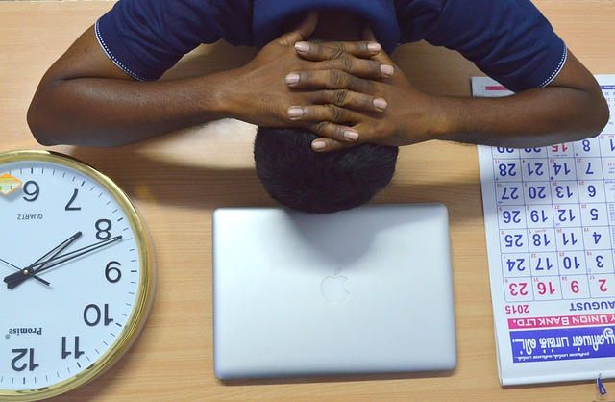

Parents Chime In

Parents, you know your child’s strengths better than anyone. However, although you may also know some of their current interests, middle school students begin to develop interests that they did not have when they were younger. Don’t assume that you know everything that your child will want to do in high school.

Ask some questions, but let your child lead the way in determining what he or she might want to do in high school. For a sample interest inventory that will be helpful to guide this discussion, [click here](http://www.slvboces.org/view/135.pdf).

Culture



As an 8th grade student, you have gotten used to being the oldest in your school. You are comfortable with the school, teachers, rules, and schedule. Not only that, but the younger students look up to you. Next year, as a 9th grader, you will become the youngest in a bigger school. This experience is going to feel a little different. But with the right preparation, it can be exciting and not scary. Here are some things to think about before the first day of high school.

Arrival at school: Lots of students will be waiting for the bell to ring to enter school. You may want to find a friend to walk in with on the first day.

Class changes: Map out the route that you will take to get from class to class so that you don’t get overwhelmed by the people in the hallway, and so that you will know where to go.

Lunch: Although it will not likely look like the *High School Musical* example where students sit in cliques and burst into song, the cafeteria will be busy and possibly hectic, and it’ll be a big deal to decide “where to sit.”

Because high schools generally combine several middle schools, there will be a lot more students in high school. High schools are set up to handle many more students, and they have programs to help you feel at home. Talk to your guidance counselor about these options:

Early orientation

School tours

Peer mentoring opportunities.

Once you get into the rhythm of high school, you will feel more comfortable and find your niche. If you find that you aren’t getting comfortable, ask your support resources for help. Your support resources include:

Teachers

Guidance counselors

Administrators

Parents

Peer mentors.

Parents Chime In

Parents, you’ve heard and experienced the old adage about moving from being a “big fish in a small pond” to being the “little fish in a big pond.” For some students, this transition may be a challenge. For others, it is refreshing. Offer suggestions and talk with your student about adjusting to their new environment. If your student seems overwhelmed, talk through some strategies that he or she can use, and consider scheduling a time for your student to talk to someone in high school now.

Course Credits

* Dance Arts
* Band
* Orchestra
* Music Theory and Appreciation
* Music: Vocal/Choral
* Theater Arts
* Visual Arts
* Trade and Industrial Education
* JROTC
* Sports Medicine
* Interior Design
* Apparel and Textile Production
* Early Childhood Education
* Foreign Language
* Printing and Graphics

In order to receive your high school diploma, you will need to pass certain classes so that you receive credit for them. These are called your course credits. Different states have different requirements. You can find your state’s requirements at the state Department of Public Instruction. These are the requirements for North Carolina.

Minimum course requirements include:

English: 3 courses/credits

Math: 4 courses/credits

Science: 3 courses/credits

Social studies: 4 courses/credits

Health/Physical education: 1 course/credit

Electives/Other courses: 6 courses/credits

The state mandates a minimum of 22 credits for graduation in addition to credits required by local school boards.

Course selection is based on your diploma pathway. But you have some options for which courses you take each semester. Often, you can select a strand or concentration of courses based on your interests or strengths. You might have even more flexibility in choosing which courses you take within that strand. You will also have a choice of electives, such as art, design, automotive, foods, drama, music, and many other options.

One fun thing about high school is the number of electives that you can take. When selecting your electives, you’ll want to consider your interests, your diploma track, and your plans for after high school.

Consider the following:

Foreign language may be considered an elective for high school graduation, but it may be required for application to a four-year university in some states.

Health and Physical Education are often taught as one course and may be required for graduation.

Here are some examples of electives:

* Parenting and Child Development
* Culinary Arts and Hospitality
* Foods
* Teen Living
* Health Sciences
* Agriculture
* Automotive Technology
* Business Information and Technology
* Drafting
* Carpentry
* Core and Sustainable Construction
* Marketing
* Welding
* Firefighter Technology
* And so much more!

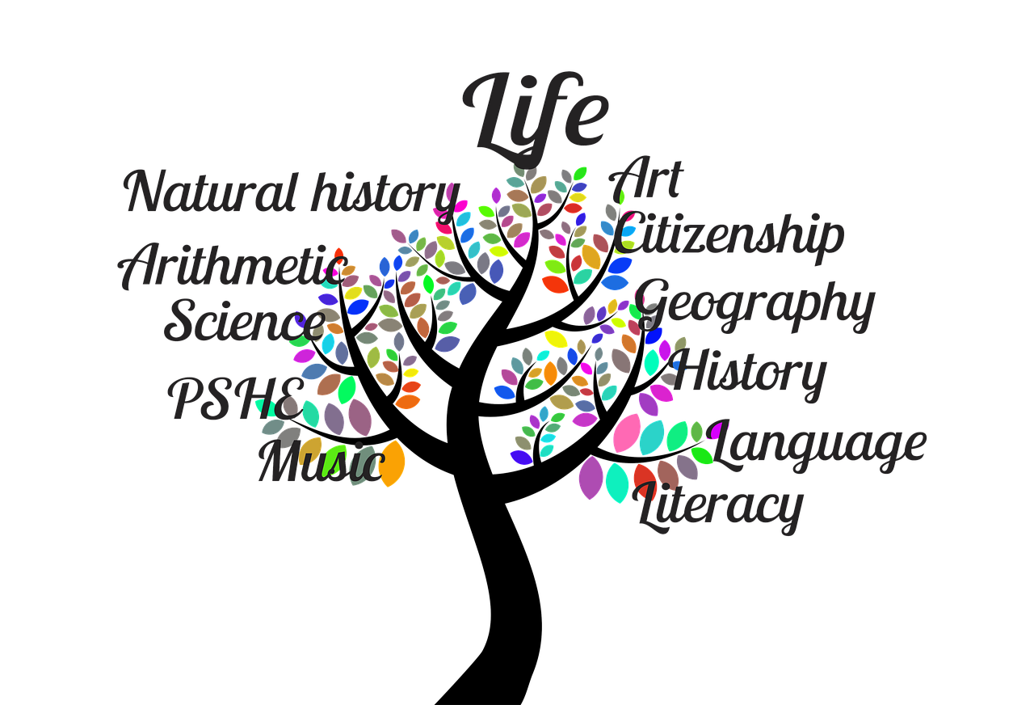

Testing

You have gotten used to taking End of Grade tests in elementary and middle school. Due to the flexibility of high school course schedules, your final tests will now be referred to as End of Course tests. These tests will look a little different for each class. Here’s what you should know.

All courses will have some sort of final exam.

Final exams often have a substantial impact on the final course grade.

Exams take place at the end of each semester.

Failing a high school exam that is required by the state could cause you to repeat the class, even if you have a passing grade in the class itself.

Attendance

High school attendance policies differ from those in middle school. Since courses are taken by semester, fewer absences are permitted.

Typically, you can only miss 5-8 days per semester per class (including both excused and unexcused absences).

If your absences exceed the local school board’s limit, you will fail the course.

Some schools have after-school or weekend opportunities available to make up absences that exceed the local school board policy.

Follow Up

Review with your parent or family member: Consider the following questions in light of what you have learned about high school in this lesson. You may want to create a graphic organizer, such as a tree map, to organize your thoughts about the different topics discussed in this lesson.

What aspects of learning about high school surprise you the most?

What are you most looking forward to in high school?

What are you most concerned about?

What are your interests, and how will you use them in high school?

Final Thoughts: Testing and Attendance

Parents Chime In

Parents, refer back to your child’s interest inventory as you are looking into which electives he or she might take. With a four-block schedule, your child will have opportunities to discover course options that he or she will find personally interesting and engaging. Use this as a time of exploration, and as the start of the process of planning future career opportunities.

Have you accomplished today’s objective?

Objective: The student will accurately describe the following elements of high school: scheduling, goal setting, GPA, decision making, culture, and course credits.

*If so, congratulations!*

*If not, review the High School examples again and discuss the questions at the end of this lesson. Have your parent review this material with you.*

**For more information…Digging Deeper:**

**I didn’t see anything for digging deeper.**