**Module 2 Part 9 – Academic Integrity**

*This section corresponds middle school transition classroom materials for Module 2 Lesson* 7.

**Introduction**

**Learn About It**

**Scenario 1**

**Scenario 2**

**Scenario 3**

**Are you a person of Integrity?**

**Talk about it**

**Academic Integrity**

**Violations of Academic Integrity**

**Cheating**

**Plagiarism**

**Falsification**

**Other Violations**

**Consequences**

**Final Reminders**

**Follow Up**

**Objective Check**

**Digging Deeper**

**Introduction**

**Objective:** You will articulate the importance of academic integrity and list at least 3 examples of academic integrity violations.

**Estimated time needed:** 30-45 minutes

**Additional materials needed:**

* Internet access
* Pencil and Paper

**Introductory Video**

*\*Click to play video*

*\**

*[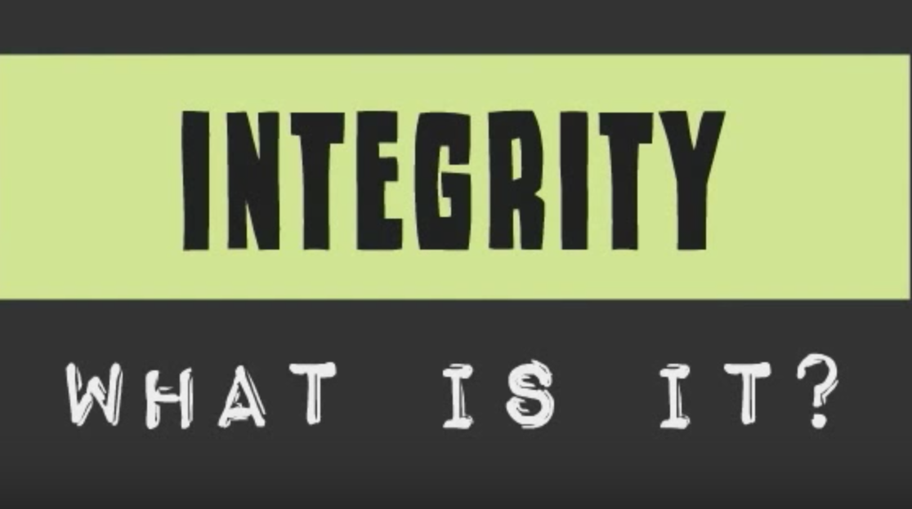](https://www.youtube.com/watch?v=2wvXEAO4Q44&index=2&list=PL0LEcCrzCkHrF6i3W_aWQXZCTzzuGViE1)*

**Learn About It**

Academic integrity. It seems like such a big concept. “Sure,” you may think, “I get help here and there, but I am mostly honest on all of the big stuff.” Take a minute to think about the words **academic** and **integrity**. What do those words mean to you? In fact, take it a step farther and actually write down what you think academic integrity actually means. Feel free to use a graphic organizer or write a few sentences. By the time you finish this section, you might have different thoughts about what having academic integrity actually means.

Once you have your definition or thoughts written down, read the scenarios below and decide if they are a violation of academic integrity or not.

You are helping a fellow student understand the math problems from last night’s homework before class begins. This is something your teacher is ok with – even encourages. To do so, you are referring to your own homework paper. Before you finish, you get called away to run an errand for another teacher and leave your paper with your friend to turn in. However, she copies the rest of your answers on her paper and shares it with another student. Did you violate academic integrity standards? Did your friend?

**Scenario #1**

You have the opportunity to get extra credit in a class by attending a local musical event. You really need to pull up your grade in that class, so you decide to go. When you get there the event is sold out. You wait around until the show is over and get a ticket stub from the event from someone who attended to turn in to your teacher for the extra credit. After all, you really did try to go to the concert, right? Did you violate academic integrity by turning in someone else’s ticket when you did not attend the event yourself?

**Scenario #2**

**Scenario #3**

You have social studies 1st period, and your teacher gives a pop quiz in class. Your best friend has the same class with the same teacher during the last period of the day. During lunch you mention to your friend that he might want to glance over his homework chapter because the teacher is giving a quiz in class that day.

**Parents Chime In**

Some of these scenarios cover a very gray area. You might not even be sure if it is a violation of academic integrity or not. Work with your child through the materials below, and we will revisit the same scenarios at the end of the lesson.



**Are you a person of integrity?**

Integrity is defined as the quality of being honest and having strong moral principles or moral uprightness.

When you are thinking about integrity, you can think about these questions to help you have a more concrete understanding of what it actually means.

* I try to do what’s right, even when it’s difficult.
* I am true to my very best self.
* I live up to the highest ethical standard.
* I don’t compromise my values by giving in to temptation.

Doing the right thing isn’t always easy. Sometimes you may find yourself in a situation where you won’t know what to do. Your character, values, and morals may be tested, but it’s important to remember not to compromise what you believe in when faced with tough situations. Think about the four statements above. You may not be perfect, but do those statements reflect how you try to live and make choices?

**Talk About it**

Having integrity goes into every area of our lives. You can think of it as what you do when no one is watching. Sometimes it can be easier to think about it in relation to people you know and then apply it to your own life. Think about the following discussion questions and then find a parent or trusted adult and talk about them. See if they have any suggestions for you. If you would rather have these discussion questions on a piece of paper where you can write the answers, you can find it here.

* What does the expression “walk your talk” mean to you? Do you know people who “walk their talk?” What do you think of them? Do you know people who don’t “walk their talk?” What do you think of them?
* How do you feel when you see someone who’s not willing to stand up for his/her beliefs?
* Have you ever taken a stand that was unpopular and had to pay the price for that? What did you do? What was the outcome? How did you feel afterwards? What did you learn from the experience?



You’ve thought a lot about integrity now, so what exactly is academic integrity?

This means that not only students but also faculty and staff must uphold the moral and ethical standards of the academic institution. Think of it this way:

* What if you wrote a story and then found out that someone else took it and published it in a magazine as their own story?
* How would you feel if you painted a picture and then next thing you know someone else entered it in a contest as their own painting?
* How would you feel if you studied really hard for a math test, but during the test, the person sitting beside you copied your test and made a good grade without ever studying?

Simply put, academic integrity means these two things:

* All academic work should result from your own efforts.
* If you use someone else’s work, you need to acknowledge that the work is not yours.

**Academic Integrity**

**Academic integrity is “the ethical policy of academics. This includes avoidance of cheating or plagiarism; maintenance of academic standards; honesty and rigor in research and academic publishing.”**

[*http://www.library.illinois.edu/learn/research/academicintegrity.html*](http://www.library.illinois.edu/learn/research/academicintegrity.html)

**Parents Chime In**

The idea of academic integrity is a big one for students to understand. Your child simply may not have accumulated enough different experiences to understand why some of the concepts are so important. Try to keep it simple by referring to the two bullets above, but at the same time stress the importance of being honest and open at all times with academic work. Give examples from your family’s experiences – or situations you know your student has experienced to drive these ideas home.

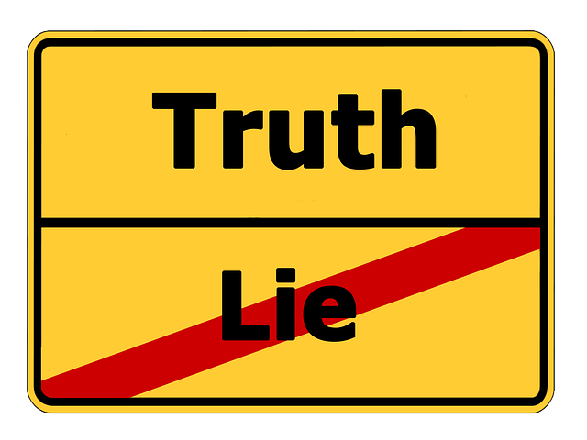

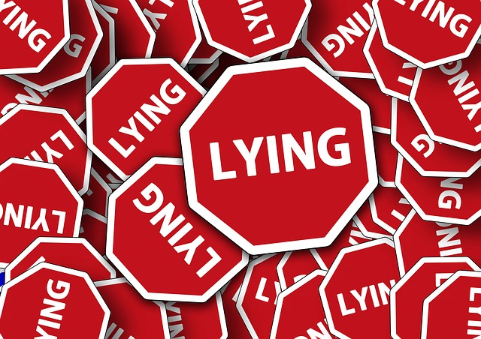

Cheating can take many different forms. Sometimes you may not even be realizing that you are cheating because it isn’t on something as high-stakes as a test. It is important to know that it applies to any assignment. Here are the basics.

* Using unauthorized materials or methods
  + Example: Using a calculator when you aren’t supposed to or using a computerized translation program
* Receiving or giving unauthorized help
  + Example: Copying homework or a worksheet from another student or looking at a textbook during an online quiz
* Receiving or giving an unfair advantage

Here are some ways to make sure that you are not cheating.

* Complete your work exactly as your teacher assigned it
* Get to know your teachers. You have different teachers in high school and each teacher has a different preference and expectation. Take the time to learn exactly what each teacher expects.
* Ask for clarification. Many teachers allow group or partner work during school. This can make it difficult to know when it’s okay to share ideas and when you need to work independently. If you aren’t 100% sure, just ask the teacher for his/her expectations. The teacher may welcome this, and appreciate that you are taking academic integrity seriously.

**Cheating**

When people violate or break academic integrity, it can typically fall into one of three categories.

**Cheating**

Acting dishonestly or unfairly in order to gain an advantage. This could be cheating during a game or on a test.

**Plagiarism**

Taking someone else’s work or ideas and passing them off as your own. A good example of this is copying something that you read and not telling that it wasn’t your idea.

**Falsification**

Falsifying information or a theory. This includes forging a signature or creating a fake ID.

Let’s look at these in a little more detail.

**Violations of Academic Integrity**



What is plagiarism? Simply put, it is

* Using others’ ideas and/or words without acknowledging the source of that information
* Copying or purchasing papers from an online source or another student
* Failing to give credit for an author’s ideas that have been paraphrased or summarized

Most people know that you can’t just copy something down and call it your own, but it can get tricky when you are trying to paraphrase something to know when to cite the source. Some people commit plagiarism without even realizing it. Follow these guidelines to avoid plagiarizing.

* Short cuts with the writing process put you at risk for plagiarism. Be sure to site all photos and graphics in addition to text that you have pulled from other sources.
* If it is not in your words, use quotation marks and cite the source appropriately.
* If the ideas/content came from another source, but you put them into your own words, cite that too. Use the proper format for paraphrased information.
* Basically if it isn’t a statement that presents extremely common and accepted knowledge, it needs a citation!

**Plagiarism**

**Falsification**



Falsification is:

* Spoken or written untruths
* Misrepresentation
* It applies to coursework, emails, conversations, documents, and more



There are a few other violations of academic integrity that don’t fall nicely into the three compartments listed above. You can find examples of them below.

**Unauthorized collaboration**

* Working together on any assignment without permission to do so
* Teachers typically will let students work together for the purposes of studying and learning. Make sure that you ask for clarification when the assignment is for a grade. The safest bet is to assume that you must do all of your work independently unless otherwise given permission to collaborate with classmates.

**Compromising the security or integrity of an exam, assignment, or grading process**

* Telling a friend who has the teacher at a different time in the day what was on the quiz or even simply telling someone that there will be a pop quiz or unexpected extra credit.
* Giving someone your completed workbook or handing over your old tests to someone about to take the class.

**Helping others to violate a policy**

* Anytime you assist someone else in committing a violation, you can be held responsible.
* If you give your paper to someone and they copy it, you are guilty of violating academic integrity just as much as the person who actually copied the paper.

**Failure to report a known violation**

* At many schools, students who know about someone else’s violation, even if they had nothing to do with it, can be held responsible if they don’t report it. This reflects the idea that academic integrity is everyone’s responsibility and actions taken by others impact the school community.
* Working together as a community is necessary in order to hold everyone accountable, maintain high standards, and keep the value of the degree being earned high.

**Attempting to violate a policy**

* Beware that at many schools, you don’t have to actually go through with the violation in order to be held responsible.
* You don’t have to succeed at breaking the rule in order to be charged with it
  + Example: You are texting a friend for the answer to a question and the teacher catches you before you hit send or before you receive a reply. This is still considered a violation.

**Other Violations of Academic Integrity**

**Parents Chime In**

Whew…that is a lot of information! Your child, and maybe even you, may think that some of it is extreme. The important thing to remember is that schools take learning seriously. One reason teachers give assignments is to understand your student’s level of mastery with the material they are teaching. If a student’s performance on an assignment is inflated by too much assistance from others, the teacher will not be able to know the student needs more support and/or instruction in that content. Moreover, teachers want to be sure that the grade your child receives reflects what he/she has learned. In all cases, it is better to be safe than sorry. Work now to instill in your child the importance of maintaining high academic integrity. Saying no to cheating or handing over homework can lead to teasing, but having high standards and taking the high road is always better than taking the risk associated with things that have the potential to have extremely negative consequences.

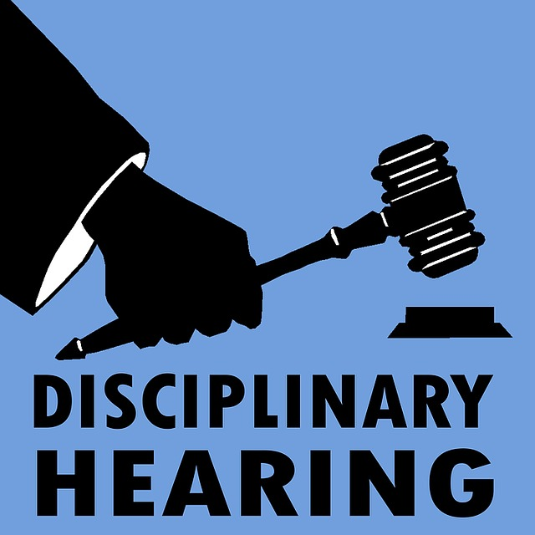

Let’s say that you or someone you know makes the mistake of violating the academic integrity standards. What happens then? Attention to academic integrity gets more and more strict as you progress through school. In middle school, you are learning about it’s value, but as you enter high school, the consequences become stricter for violations. In college, the penalties for violations can result in serious consequences such as expulsion from a program.

Each school handles the violations differently. You’ll want to check your student handbook for the consequences at your school. They will be a variation of these consequences though:

* Receiving a failing grade for the class
* Loss of privilege such as extracurricular activities, offices held, or participation on sports teams
* Character and reputation is compromised
* Credibility is lost

**Consequences for Violating Academic Integrity Standards**



**Final Reminders**

* Always give credit to the sources you use. It is better to err on the side of citing more than to take the risk of plagiarism
* Never copy from the internet, books, magazines, or other sources that are not yours. It is so easy to select, copy, and paste when working on a paper, but this short-cut can get you into a lot of trouble
* Use original thoughts
* Do your own work

Stick to these guidelines and you’ll be fine!

**Follow Up**

**Review with your parent or family member:** Look back at the graphic organizer you created at the beginning of the lesson and see if you have anything else to add to it. Also revisit the three scenarios from the beginning of the lesson. Do you feel any differently about them now that you have more information? These were all examples of violations of academic integrity. Discuss with your student different steps the student could have taken in each scenario to avoid violating this important school code.

**Have you accomplished today’s objective?**

**Objective:** *Can you articulate the importance of academic integrity and list at least 3 examples of academic integrity violations?*

For a more concrete assessment of this objective, use the handout found here.

*If so, congratulations!*

*If not, review the section on academic integrity violations again and discuss the questions at the end of this lesson. Review this information with an adult.*

**For more information…Digging Deeper:**

Academic Integrity: Cheat or Be Cheated

<http://www.edutopia.org/blog/academic-integrity-cheat-or-be-cheated-denise-pope>

Character: Academic Integrity

<http://character.org/key-topics/academic-integrity/>

Academic Integrity at MIT

<https://integrity.mit.edu>

Academic Integrity

<http://integrity.ou.edu/students.html>