Module 2 Part 7 – The Basics of Self Disclosure

This section corresponds with middle school transition classroom materials from Module 2 Lesson 6.

Introduction
Learn About It
What is Self-Disclosure?
Self-Disclosure Now
Self- Disclosure After High School
Informal Self-Disclosure
Formal Self-Disclosure
Things to Consider
Risk or Reward
What Make Self-Disclosure Successful?
Wrapping up
Objective Check
Digging Deeper
Introduction
Objective: You will
- Identify the risks and rewards in both formal and informal self-disclosure situations
- Build an outline for successful self-disclosure in both formal and informal situations.
Estimated time needed: 30-45 minutes
Additional materials needed:
- Internet access
- Pencil and paper

Introductory Video
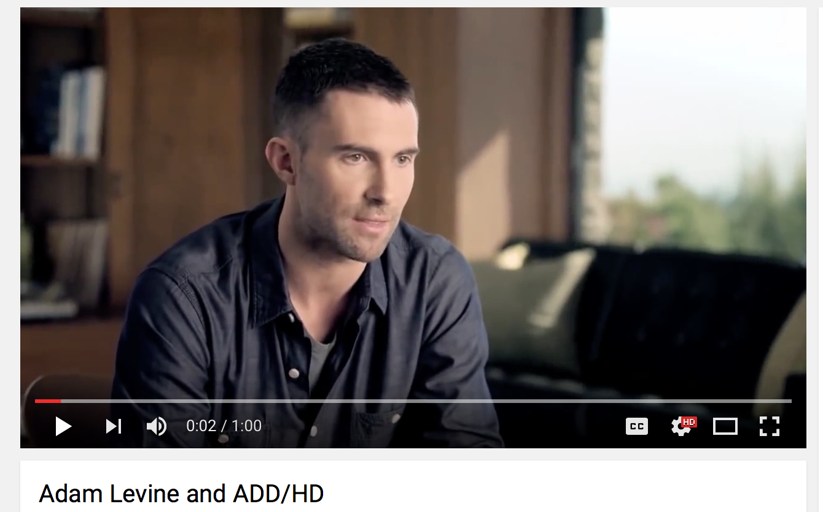

Parents Chime In

The perfection complex that is permeating our society has even affected adults. Instead of trying to be perfect or put together all of the time, allow your child to see your flaws and mistakes. Your child needs to see you working through difficult situations and how you handle your flaws in order to have the skills he/she needs to overcome challenges.
Learn About It
It can be hard and even embarrassing to talk about the less than perfect parts of your life. Social media allows people to put their best face forward at all times and shows the really good parts of people’s lives. In a world full of Pinterest bedrooms, prom proposals on YouTube, and edited selfies on Facebook, it is no doubt that people are less than thrilled to talk about their imperfections. After all, everyone else is perfect, right? Wrong! As you saw in the video above, people are not perfect, and many people are willing to talk about it. Having a disability is part of what makes you, you. It doesn’t define you, but it is a piece of the puzzle that is the masterpiece of you! Once you understand that, it becomes much easier to talk about your disability.
What is Self-Disclosure?
The basic definition of self-disclosure is
the purposeful disclosure of personal information to another person
This basically just means that you are making an intentional decision to tell another person something about yourself. There are different levels of self-disclosure.
- Superficial: family information such as the number of brothers and sisters you have, where you are from, your favorite sports teams or music that you like
- Private: personal information that goes deeper into who you are
For today’s purposes, you are going to learn about the decision you have to disclose information to others about your learning disability.

Self-Disclosure Now
You may feel that most people around you know about your leaning disability. After all, your teachers and school representatives were probably part of the process when you identified your disability. Plus, your friends know that you go to special classes during the day to help you learn. But what about those people on your sports teams or at summer camps? What about people who don’t go to your school? Do they know about your disability? One day down the road, you will graduate from high school, and you will have a decision to make. You will need to decide who you tell, how much you tell, or if you even want to tell at all. These are important decisions and the best way to make those decisions is to be as prepared as possible and to start practicing now. Then you will be able to make informed, confident decisions when the time arises. In the meantime, think about these things.
- Who already knows about your disability?
- Who doesn’t know about your disability?
- You have the option to tell others or keep it to yourself
- Disabilities don’t disappear once you graduate from high school
Self-Disclosure After High School
Once you graduate from high school, you will leave an environment where most people know about your learning disability and enter one of two new environments. You will either enter the work force or go to college to continue your education. In either case, you now have a decision to make. For the first time in your life, you have the option of telling people about your disability or keeping it to yourself. Only you can make this decision, and it comes down to
risk versus reward
As you learned earlier, there are laws in place to offer you support and protect you from discrimination, so your decision is based on your perceived risk of telling others versus the reward of the supports you may need to help you succeed. This is a personal decision, but you need to seriously consider both sides. Obviously, it isn’t a decision that you need to make right now, but it is important to begin thinking about the decision now. The more practice you have in talking about your decision, the more comfortable you will be with knowing what to say. This will make you more likely to continue to self-disclose your disability once you graduate. Remember, you are simply telling others the full story of who you are.

Informal Self-Disclosure
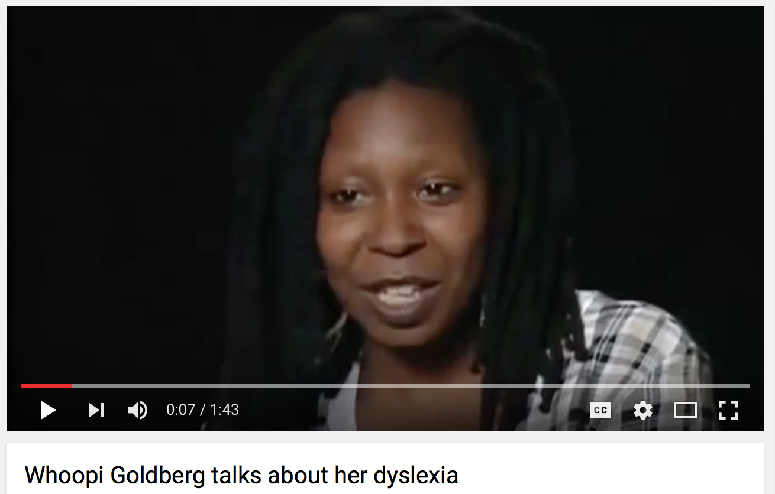

In this video we see Whoopi Goldberg talking about her disability as a child. While she is doing it for the camera, it is a more informal conversation. She is telling her story almost as if she were telling a friend, and she is not ashamed because her disability has helped her become who she is today.
While you are in middle and high school, most people will know about your disability, but as you transition into adulthood, you will have new friends and be in new social situations. For example, in college you will have people in your classes, your dorm, organizations, or even your part time job that you are meeting for the first time. Some of these friendships will develop into lifelong friendships. These situations lend themselves to informal self-disclosure. With these new relationships, you have a risk versus reward scenario.
The risk is the person’s reaction. Is it a new roommate, a classmate, or someone in a social organization? What will they think of you? Will they want to be your partner in class anymore? Will they ask a lot of questions? Will they understand and be supportive?
The reward is that you will not have to hide your disability from them. You won’t have to tap dance around answers and wonder if they are ever going to find out. You also won’t have to get to the place in your friendship where you should have already told them but haven’t, and now it is awkward to say it. The biggest part of the reward is that you get to be you. You don’t have to pretend to be something that you’re not. Even in informal situations, you have to decide if the risk is worth the reward.
Formal Self-Disclosure
Formal self-disclosure serves a different purpose. When you are in informal situations, you are telling people a piece of who you are to
- build relationships
- help someone see things from a different perspective
- encourage someone to overcome obstacles
The purpose of formal self-disclosure is to get accommodations that will help you to be successful whether at school or at work.
You know the laws that are in place for your protection, but it is your responsibility to disclose your disability. No one is going to find you and make sure you are receiving your accommodations. It is up to you to complete the process that your college or workplace has in place, and advocate for what you need to be successful. The process of doing this is much different than the informal process of telling your friends. It is much more professional. Again, you will need to evaluate the risk versus the reward for formal self-disclosure.
The risks include
- going through the process and then being denied accommodations
- having professors that don’t look favorably on accommodations
- being nervous about telling a professor
- classmates making judgmental evaluations based on their perception of your accommodations
The reward is
- having the supports in place that will allow you to master the content of the course
- show your professor your successful mastery of the content
Once again, practicing and becoming comfortable with telling others about your disability increases your confidence and makes it much easier to disclose your disability in a formal situation.

Risk or Reward, Formal or Informal
This is another activity like the one in the Law Family Materials. I have a list of them and an answer key so that they could print them out and then check their work, but I think it would be better to create it online. I don’t know if this is something someone else knows how to do.
Now you’ve read about the risks and rewards of self-disclosure and you understand the difference between informal and formal situations. Now it’s time to apply what you know. Read each of the scenarios and decide if it is
- An informal risk
- An informal reward
- A formal risk
- A formal reward
Now, think about some of the examples you just read. Jot down two things that stand out in your mind.
- One formal risk OR reward
- One informal risk OR reward
If you wrote a risk, tell why you think it is a risk. If you wrote a reward, tell why you think it is a reward.
Things to Consider
Before you can truly weigh the risks versus rewards of your formal self-disclosure, ask yourself the following questions:
- What are your areas of weakness?
  - Organization
  - Attention
  - Auditory processing
  - Reading/writing skills
- Will the class or job require you to work in an area of your weakness so that an accommodation would be very beneficial?
- Does the class mostly focus on areas that you have strengthened so that you feel confident in your abilities without accommodations?
- Is it a large class or a small class?
- Are there tutoring resources or support services available that relate to the class?

What makes self-disclosure successful?
Successful self-disclosure begins now. You need to know your strengths, and at the same time understand your disability. Now you have supports in place that can help you understand how to talk about your disability. These supports include
- your parents
- your teachers
- other school representatives
- your doctor
Click here and use this form to help organize your thoughts. The way that you disclose information about yourself will depend on the context of the situation – formal or informal. Once you have completed this form, you will be ready to begin practicing.
To read more about self-disclosure visit
http://www.greatschools.org/gk/articles/disclosing-learning-disabilities/

Wrapping Up
The most important thing you can do is to put yourself in situations that build your confidence. Begin by telling someone that you trust. Practice telling your parents or your best friend and get their feedback. Then you can practice on a teacher or someone else that you trust. Once you have practiced in a safe environment, you’ll be much more comfortable with your words and be able clearly explain your disability and the accommodations that you need.

Have you accomplished today’s objective?
You will
- Identify the risks and rewards in both formal and informal self-disclosure situations
- Build an outline for successful self-disclosure in both formal and informal situations.
If not, review the information on the basics of self-disclosure again. Have your parent/guardian review this with you.
For More Information…Digging Deeper

Disclosing one’s learning disabilities in young adulthood
http://www.greatschools.org/gk/articles/disclosing-learning-disabilities/
Gerber, P. J. & Price, L. A. (2005). To be or not to be LD: Self-disclosure and adults with learning disabilities. Thalamus 25:18-29.

Self-Disclosure Decisions of University Students with Learning Disabilities
http://files.eric.ed.gov/fulltext/EJ1074663.pdf

Self-disclosure
http://2012books.lardbucket.org/books/a-primer-on-communication-studies/s06-04-self-disclosure-and-interperso.html

