Module 2 Part 6 – Know Your Rights: Understanding the Law

This section corresponds with middle school transition curriculum classroom materials for Module 2 Lesson 5.

Introduction
Learn About It
Laws for You Now
Laws After Graduation
Americans with Disabilities Act
Workplace Supports
Section 504
Accommodations and Modifications
Expectations of Colleges
Typical College Accommodations
Show What You Know
Wrapping Up
Objective Check
Digging Deeper
Introduction
Objective: You will identify and compare the three main laws protecting individuals with disabilities.
Estimated time needed: 30-45 minutes
Additional materials needed:
- Internet access
- Pencil and paper

Introductory Video
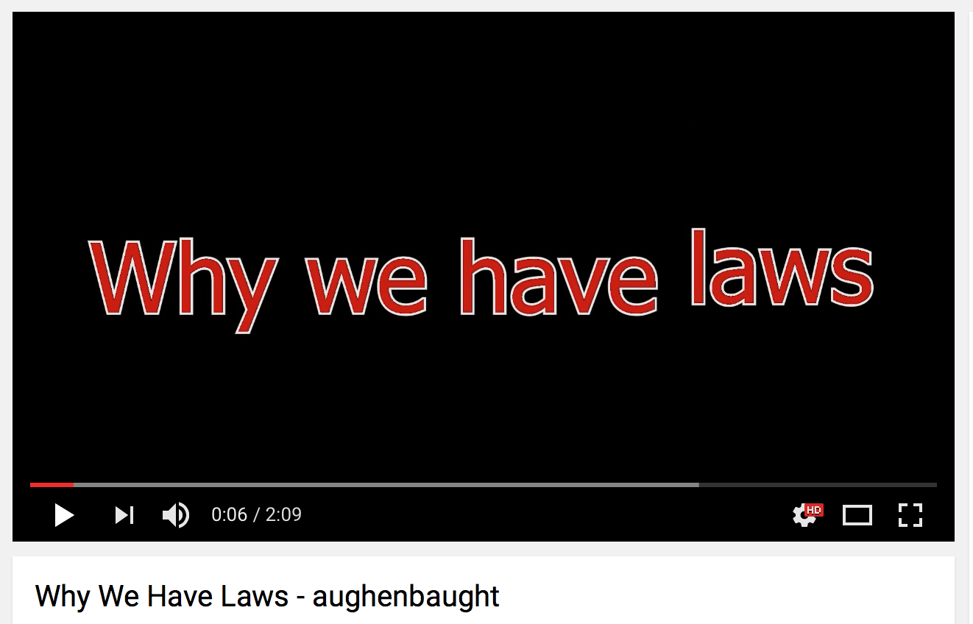

Click on the image above to play the video.

Learn About It
From the time you learned to walk, you have known about laws and rules. There are rules for practically everything and every situation! While some rules seem pointless, it is necessary to have rules in order for groups of people to be able to live together. In particular, today you are going to learn about three laws that were created to help people with disabilities be successful. These laws all have slight differences, but by learning about them, you will know your rights and the supports that you have available to you. If you aren’t aware of your rights, then it is difficult to make decisions that are best for you.
Parents Chime In
Reading and understanding wordy laws can seem overwhelming. Thankfully, there are many resources available to help break down the laws into understandable pieces. By taking the time to understand the laws that are in place to help people with disabilities, you will be helping your child more than you know. So hold on for the ride, and jump right in!

Laws for You Now

The IDEA law was written in 1975 and has evolved over time.
The purpose of IDEA is to ensure that all children with disabilities are able to have access to the same curriculum that other students learn.
Children with disabilities are covered under this law as soon as they are born, and it continues to cover them through high school graduation up to age 22. If you can name some of the accommodations and modifications you receive in school, IDEA is the umbrella that covers them. It covers everything from:
- Being identified.
- Receiving an IEP.
- Parent involvement.
- Accommodations/modifications.
- Handling behavior issues.
- Making the transition to adulthood.
- Resolving disputes.
While this law is very thorough and provides important supports, what is in place to offer protection and support after high school?
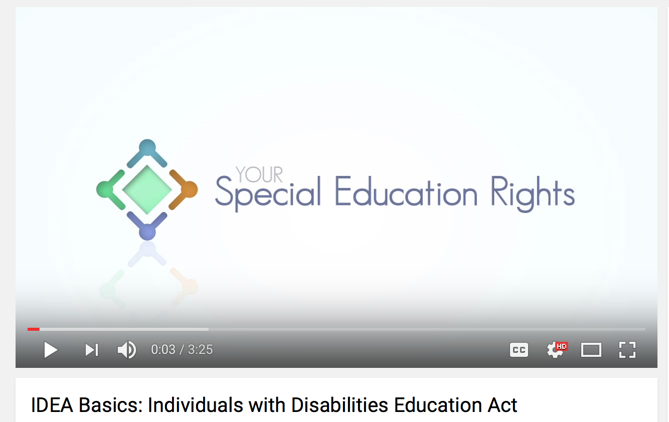
US Department of Education http://idea.ed.gov
Parent Center Hub: general overview of IDEA

Laws in Place After Graduation
Section 504 of the Rehabilitation Act | ADA: Americans with Disabilities Act
Applies to post-secondary education (college) | Applies to the work place
Americas with Disabilities Act: ADA
One of the most important things for people with disabilities to know is that there are laws in place to help them after graduation from high school. One of those laws is the Americans with Disabilities Act (ADA). This civil rights law is in place to protect individuals with disabilities from discrimination in
- Employment.
- State and local government.
- Public accommodations.
- Telecommunications.
It provides legal covering to ensure that people with disabilities have access to accommodations that they need in order to have the same rights and opportunities as the general public. While this law encompasses the workplace environment, it also covers colleges and universities.
Workplace Supports Through ADA
While the ADA does make sure that people with disabilities have accommodations, they have to be accommodations that are not going to make it difficult for the employer to continue to be successful. It must be a reasonable accommodation that doesn’t affect
- Job production or quality
- Take away an essential job function
- Create undue hardship for the employer
Examples of reasonable accommodations include
- Modifying equipment or facilities
- Working from home or changing work schedule
- Providing readers or interpreters
Also, accommodations must be linked to a medical disability.

Section 504 of the Rehabilitation Act
All the way through school, you have been protected by a law that requires school representatives and teachers to provide accommodations and modifications that support your success. This process is unique to all individuals based on specific needs. Not only are these supports in place through school, but the teachers and representatives keep up with the paperwork, setting up the meetings and providing ideas for what will help you. Their expertise guides the process. While this is well known to most people, what happens after graduation isn’t as well known. As a student with a disability, you are still provided protection and support when you go to college. It will look different and your role in the process changes, but you may still qualify for some of the same supports you have had before. It is important to remember
- Section 504 picks up where IDEA stops and continues through college
- Applies to all educational setting that receive federal funding
  - Very few small, private institutions do not receive federal funding
- The purpose is to make sure colleges do not turn away a student because of a disability
- The college board determines if you are a “qualified individual”
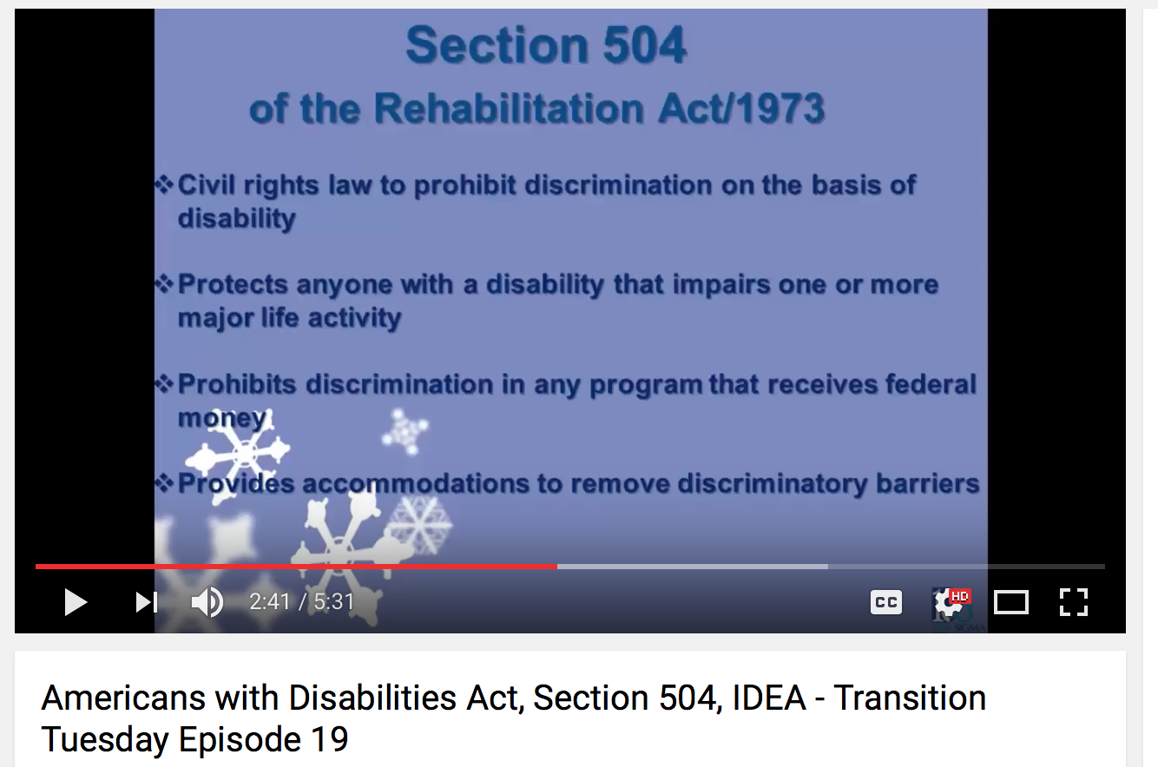
To watch this video, click on the image above.
Parents Chime In
Well, these are the three big laws. They aren’t that complicated when you break it down, but understanding them will help you support your child. Go back through what you just learned with your child and do a quick review to make sure that you both can see the differences in the laws.
Accommodations and Modifications
You’re going to switch gears for a minute and talk about two words so that you can understand what comes next. You have heard the terms accommodations and modifications many times before. While both of these words refer to the supports you receive in school, they are actually just a little bit different.
Accommodations change how a student learns the material taught in class.
- Extra time
- Audio books
- Writing assistance
Modifications change what a student is taught or expected to learn.
- Shorter or easier reading assignments
- Shorter tests
- Less detail in certain content areas
Depending on your disability, you may only have accommodations or you might have a combination of both.
To read more about this topic visit
https://www.understood.org/en/learning-attention-issues/treatments-approaches/educational-strategies/the-difference-between-accommodations-and-modifications

Typical Accommodations in College
One of the major differences in middle school/high school and college, and therefore in IDEA and Section 504, is that you are responsible for advocating for any accommodations you need to receive. While they are not going to change the course content you are responsible for, you may qualify for accommodations that will help you master the content and/or successfully show your mastery of the content through tests and papers. Getting a course substitution can be difficult, but it is not impossible. For example, if you are majoring in a non-math degree, you may be able to substitute a different course for a general math requirement. Some examples include
- Priority registration
- Exam modifications (i.e. extended time on tests, readers, scribes, proctors)
- Testing in a room with limited distractions
- Interpreters
- Textbooks in an alternate format
- Course substitutions
The most important part of the process though is to go to the office of disability support services coordinator and start the conversation so that you will know what is available.
To read more about this topic visit
http://www.going-to-college.org/campuslife/accommodations.html
Expectations of Colleges
Under Section 504, all colleges and universities should have a coordinator for Disability Support Services (DSS) or a 504 coordinator. This is where you will go to complete the paperwork or determine the supports available to you. You will have to set up an appointment and provide appropriate paperwork or documentation from a licensed professional. An old IEP will not be acceptable. Once you have been approved, your support will be discussed. While IDEA may have allowed you to received modifications in middle and high school, colleges are not under that rule, and typically do not make modifications on the curriculum they expect you to learn. As a student at their institution, you are responsible for learning the content that they are teaching in their courses. Accommodations that you need in order to learn the material are provided though.

Parents Chime In
Talk to your child about the accommodations and modifications he/she currently receives in school. List them out and then decide if each one is an accommodation or a modification. Talk about the differences.
Show What You Know
Click here to see the different sentences relating to the three main laws you learned about today: IDEA, ADA, and Section 504. See if you can sort the sentences so that they correspond to the correct law.
Answer Key

Wrapping Up
College can seem so far away, but you learned today that it isn’t impossible to go. There are laws that protect you now and laws that will provide services for you after graduation. Think about someone who is in college now. Write three questions you would like to ask someone with a disability who is in college now or has recently graduated. If you don’t know anyone, your parents or teachers might know someone. Their answers can help you understand that college is possible for you!

Have you accomplished today’s objective?
You will identify and compare the three main laws protecting individuals with disabilities. If so, congratulations!
If not, review the information on knowing the laws again. Have your parent/guardian review this with you.

For More Information…Digging Deeper

Americans with Disabilities Act Basics: Video
https://www.youtube.com/watch?v=X4rYDdW33P4

IDEA video
https://www.youtube.com/watch?v=3XMndYNEGFA

ADA Information
visit http://www.ada.gov/cguide.htm

IDEA information
http://idea.ed.gov

Section 504 of the Rehabilitation Act
http://www2.ed.gov/about/offices/list/ocr/504faq.html

